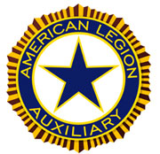
American Legion Auxiliary
Membership Guide
2017-2018

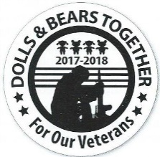

National Membership Chairman – Donna Ray (Dept. of Ohio)
Central Division Chairman-Karen Lowe (Dep. of Indiana)
Department Chairman-Darlene Jones (377-18th)
5425 Pine Knob Lane
Clarkston, MI 48347 (248) 460-3405
Eastern Area: Pat Lozano (119-6th)
4459 Harp Drive
Linden, MI 48451 (770) 778-8825
Western Area: Deb Chambers
847 fourth St NW
Grand Rapids, MI 49504 (616) 570-0817

As the world’s largest women’s patriotic service organization, the strength and influence of the American Legion Auxiliary is derived from its members. The Membership Committee works to ensure the future growth and prosperity of the organization by partnering with units, departments, and divisions to develop strategies to retain current members, recruit new ones, and engage all in mission-related activities. Current members renew their memberships when they believe the Auxiliary continues to offer them something of value for their lives.
https://www.alaforveterans.org/Members/Membership is an excellent resource for all your membership needs.
Membership is declining, you may ask why? Here are some reasons.
Barriers to Membership
• Too much reliance on membership chairman. – Job too big for one person or one committee…. Membership is everyone’s job! – NEC’s & dept. leaders need to help membership chairs/committees
• Too much reliance on technology for communication. – Personal calls & visits are key!
Why we need members!
Our mission is as important today as it was 98 years ago! Our mission will still be important 50 years from now
The question is: What will you do to grow our membership so that the Auxiliary is here for as long as our veterans need us?
What you can do
• Be an example in your department
– Treat all members with courtesy & respect
– Encourage unified effort – working programs/ events & fun socials – Share personal experiences to change how members interact
– Support women who want to honor their veteran(s) through membership, but not be active members • Provide opportunities for them to participate if interested … don’t criticize if they don’t!
“We should not require members to attend meetings but rather show them their options for meaningful engagement.”
Focus on Juniors – Junior Activities program designed to be feeder system for membership – a good way to grow membership over time – BUT, need different type of engagement
• Younger members don’t want to sit in meetings – they want to be engaged in carrying out the mission. – Find women who love working with youth to build up program, I believe the Juniors program is underutilized as a membership recruitment tool.
• Make Membership Meaningful!
• Focus less on how MANY members belong, more on WHY people belong
A “goal” is not the reason to grow membership … we need members to deliver our mission to the next generation.

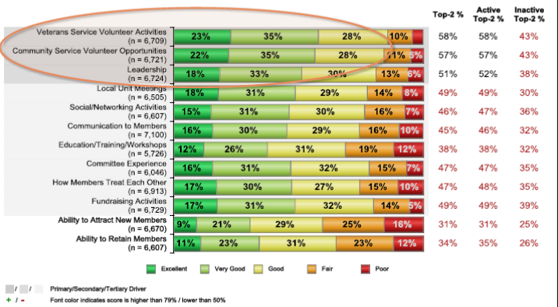
What We Can Do
Encourage & lead necessary change in your Dept. to ensure:

– Courtesy & respect for all members, regardless of how they pay dues or their level of involvement
– Positive communication reaching district and unit levels – Productive, mission-related events at unit level
• Help make membership meaningful! Have fun let’s make people want to join us.

Dolls and Bears working together to build something that will live on for another 100 years.
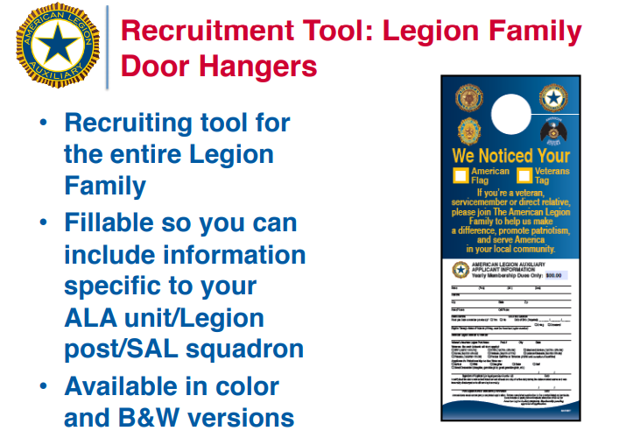
• Available for download: – www.ALAforVeterans.org/Resources/ Marketing
---Promotional-Materials
• How-to sheet included with printing instructions: – At-home printing – Professional printing
• Learn more: – See the May 2017 issue of Auxiliary magazine for details

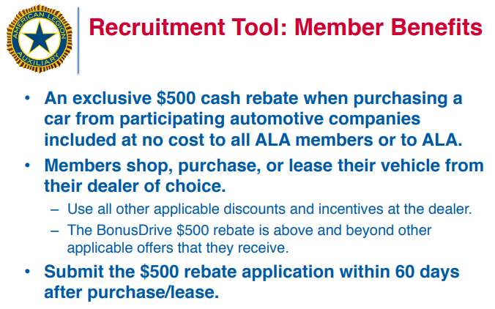
Chrysler Dodge Jeep RAM FIAT Hyundai www.ajg.com/BonusDrive-association

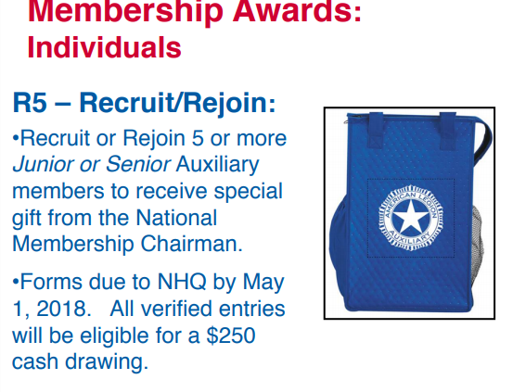

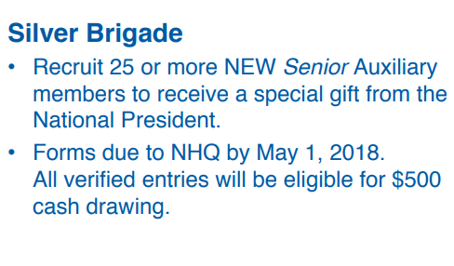

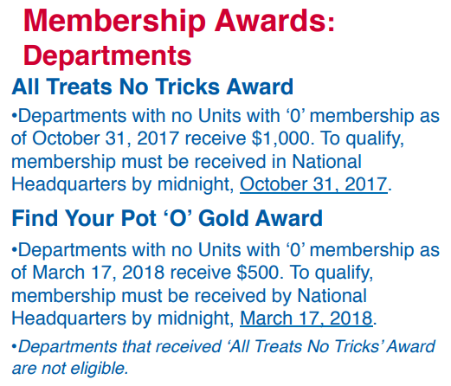

Department Membership Awards

Welcome to the 2017-2018 Membership Year. President Deanna and I are very excited to get this year’s program under way. There will be some very exciting awards and contests this year. Below are some of the rewards that your units and Districts have a chance to win:

All Districts with zero goose egg units at Fall Conference will be entered into a
drawing for $50.
All additional Districts with zero goose egg units by October 31 will be placed into a
drawing for $25.
District and units with the highest increase in membership by % not numbers will be put in for a drawing and will all receive a special gift.

For the unit that hit all targets Dates set up by National, they will also get a special award, to be announced at Fall Conference.

President Deanna will make a $50 donation to the District President’s special project for the 1st District to reach 100%. Deanna and the Membership Team are working hard to insure we meet all National Goals. If we can help you in any way do not hesitate to call on us.

