To _______________________________________________________
for making patriotism a priority!

Thank you for flying our U.S. Flag.
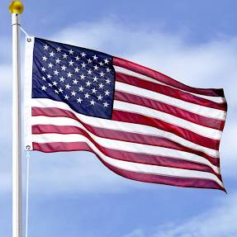
The American Legion Auxiliary

From____________________________________ God Bless America!

