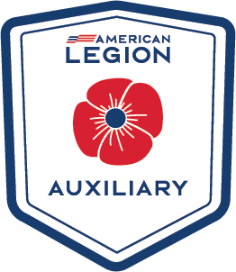
ENCOURAGE your students to take advantage
of the scholarship opportunities
through ALA

Applications must be in by March 1^{st, 2023}. It takes about 30 days for a student to prepare and submit their application.
TIME IS SHORT - GET THE WORD OUT NOW
Available Michigan Department Scholarships
Memorial Scholarship
Non - Traditional Scholarship
Medical Scholarship

The Michigan Department Scholarships information and applications are found at https://michalaux.org/scholarships

Available National Scholarships
Children of Warriors National President Scholarship
Spirit of Youth Scholarship
Non - Traditional Scholarship
Junior Member Loyalty Scholarship

The NATIONAL Scholarships Information and applications are found at
https://member.legion-aux.org/member/committees/education/national-scholarship-resources-faq

If you have any questions contact Education Chair Fran Babbage at Cell and/or text (313)408-3909, or email: franbabbage@yahoo.com
You can also contact Michigan Department Executive Director Shannon Werner at (517)220-2746, or email: shannon@michalaux.org

