Southeast Michigan
Four Chaplains
Interfaith Memorial Service

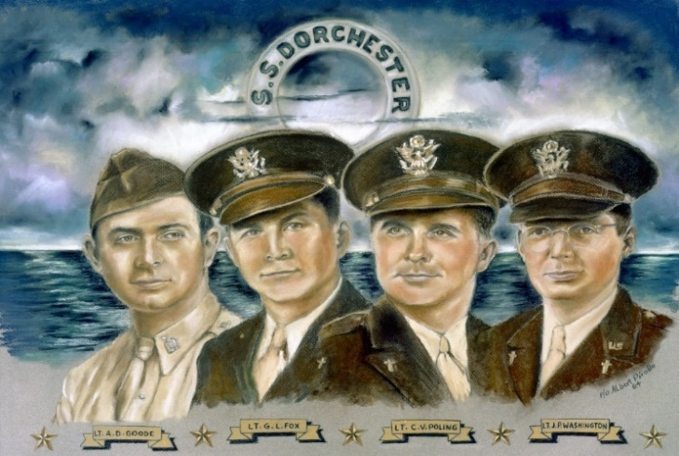

Feb. 3, 1943

ALL are invited to attend this service and learn about these 4 heroic men of Faith and their final voyage.
Held at American Legion Post 377 4819 Mary Sue Ave. Clarkston
Sunday, February 5th, 2023
@ 2:00 p.m.

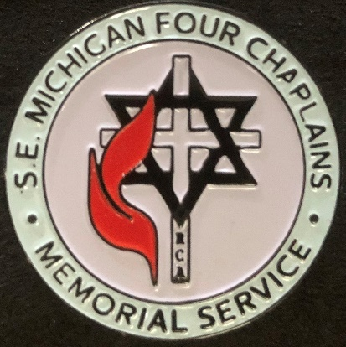
Bring your family, friends, and youth, learn and help keep their story alive.

