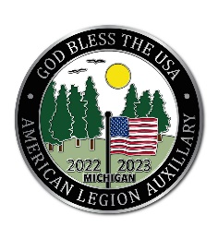
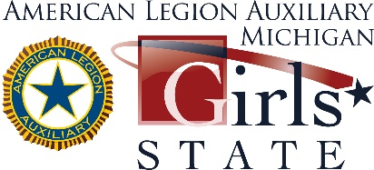
DELEGATE APPLICATION
June 18 - June 24, 2023 at MSU
www.michalaux.org

Name: Date of Birth:

Address: City: Zip Code:

School: Legal inhabitant of U.S.? Yes No

Phone: E-mail: Grade*:
* The ALA Girls State leadership development program is a week-long program for high school students who complete their junior year in 2023. Participation is limited to females, as evidenced by her birth certificate or a sworn statement signed by a licensed medical doctor.

Name(s) of Parent/Guardian:

Parent/Guardian address:

Parent/Guardian Daytime/Evening phone number(s):

Please list or describe (attach additional pages if needed):

- Applicant, please provide a brief bio of yourself, including
  - school activities
  - outside school interests/hobbies
  - awards received in school/community
  - work and/or volunteer experience

- Is any family member currently serving in the military?
  - If so, who?
  - Relationship to applicant

- Are you a direct descendant of a veteran: Yes ___ No ___
  - Relationship

- Are you considering a military career? Yes ___ No ___

- Have you applied, or do you plan to apply, to any of the U.S. Military Academies? Yes ___ No ___

- What are your future goals?

- Why do you think you would be a good candidate to represent your community at ALA Girls State?

- Do you know anyone who has attended ALA Girls State or AL Boys State; if so, who?

- Does anyone in your family belong to The American Legion or the American Legion Auxiliary; if so, what Post or Unit?

Section 2 – Applicant Eligibility Verification

⇨ Eligibility to participate in ALA Girls State
High school girls eligible to participate in the ALA Girls State/Girls Nation programs must have completed their Junior year of high school and have at least one semester of high school remaining, be a United States citizen or legal inhabitant of the United States as evidenced by a current and/or valid birth certificate, visa, passport, Green Card or other United States government-issued documentation verifying a legal presence in the United States for at least the duration of the ALA Girls State/Girls Nation program.

⇨ Documentation Requirements
I attest that my daughter (ward) has a U.S. government-issued birth certificate or legal documentation of her legal presence in the United States provided by the U.S. government (e.g. visa, Green Card, passport).

⇨ Applicant Health Information
I certify that complete and accurate health information will be provided when registering online. A link to the online registration will be provided once my daughter receives her delegate letter and a signed consent form, the registration processing form, and the $25 registration fee has been mailed to the ALA Girls State Chairman.

⇨ Eligibility to participate in ALA Girls Nation
For any girl to be eligible to take part in the ALA Girls Nation program, she must be able to clear a background check by the United States government, the White House and the U.S. Secret Service.

⇨ Eligibility to Serve in an Elected Office
The purpose of the ALA Girls State program is to provide a nonpartisan participatory program that teaches eligible high school females responsible citizenship grounded in ethics, the principles of our nation’s founders and respect for God and Country. For consistency among the 50 states presenting ALA Girls State programs, each program should conform to the structure of its corresponding state government as specified by its state constitution. ALA Girls Nation is modeled after the provisions in the United States Constitution.

We both certify that the answer to each question above is correct and verify that we have read and understand the applicant eligibility requirements.

Applicant’s Signature Parent/Guardian’s Signature

Dated:

DEADLINE FOR ACCEPTING APPLICATIONS IS MAY 1, 2023

NOTE TO APPLICANTS: Return this application to either your school counselor or sponsor if you have one. If your counselor is not working with a sponsoring organization, and you need a sponsor then please email this application to alamigirlsstate@gmail.com or mail a copy to Beryl Robbins, 1112 5th Street, Wyandotte, MI 48192 and we will locate a sponsor for you. Once accepted you will receive a letter from your sponsor with information on how to register online. When registering online you will be a charged a $25 non-refundable registration fee. Students/Counselors/Parents: If you have questions, please contact Chairmen Beryl Robbins at 313-318-6845 or Rysta Brown at 989-254-7252 or email us at alamigirlsstate@gmail.com. Additional information is available at www.michalaux.org, click on ALA Girls State.

