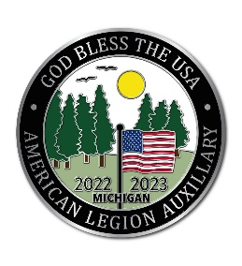
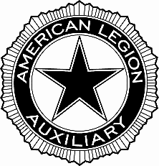
American Legion Auxiliary
Department of Michigan
212 N. Verlinden Ave, Ste. B • Lansing, Michigan 48915
517-267-8809 • michalaux.org
__________________________________________________________________________________________

TO: American Legion Auxiliary Department of Michigan DEC, Chairmen,
Unit Presidents
FROM : Marcy Jorae, Department President
DATE: May 1, 2023
RE: 2023 Department Convention & Important Items to Note

In an effort to prepare everyone for the 2023 Department Convention - the DEC, all Districts and all Units are receiving this packet with the proposed changes to the governing documents and resolutions received thus far. This is in accordance with the Department Bylaws, Article IX – Amendments, Section 1 which reads “These Bylaws may be amended at a Department Convention by a two-thirds (2/3) vote of authorized delegates or alternates present and voting, provided the proposed amendments be written in resolution form and have been read to the Convention at a previous meeting or have been distributed to all Units in printed form at least forty-five (45) days before the annual Department Convention.”

If Department does not have an email address for a Past Department President or at least one Unit Officer, you will also find included in this mailing the 2023 Department Convention General Info and forms (registration, flag registration, flower order form, Delegate/Alternate registration form and Delegate-at-large form). This information will also be posted on the Department website www.michalaux.org.

If you are a Unit President, do not have an email address on file with Department, and only received the proposed changes to the governing documents in this mailing, please check with your Unit officers to see who received the email containing the 2023 Department Convention General Info documents. In a cost-saving measure, Department is and will continue to use electronic communication whenever possible. Please keep in mind these documents are available on the Department website. We thank you for your understanding in this matter.

If you are a Unit President, please remember that your 2023-2024 Unit Data Form was due to Department by May 1, 2023. This is the form that indicates how much your dues for the 2023-2024 year will be. Please keep in mind that the minimum we can report to National for a Unit’s senior dues is $31.50. That breaks down into $18.00 for National dues and $13.50 for Department dues. Of the $13.50 for Department dues, $5.50 goes towards the Mandatory dues fund and $8.00 towards general membership dues. Your Unit may choose to charge less than $31.50 and subsidize the balance through fundraisers or other means, but keep in mind that any member choosing to pay online will be charged $31.50 and the Unit will need to work out a plan to compensate the member. Junior dues will remain at $4.25 ($2.50 for National dues and $1.75 for Department dues.)

The 2023-2024 Unit Officers List is due to Department by June 1, 2023. This form is available on the Department website. If possible, please fill this out and submit it online as it will automatically populate in the Department database. If for some reason that is not something you can do, please print off the form, complete and mail in. Please do not create your own form. Fill the form out as completely as possible.

Both forms (the 2023-2024 Unit Data Form and the 2023-2024 Unit Officers List) must be received at Department Headquarters before your 2023-2024 Membership packets will be sent to your Membership Chairman. Packets will be mailed out after the 2023 Department Convention.

I would like to thank everyone for their efforts this year in serving our Veterans, our military and their families, our children and youth, and our communities. I look forward to a good Department Convention where we can learn of and celebrate all the accomplishments of this year.

Marcy Jorae, Department President
American Legion Auxiliary
Department of Michigan

