RESOLUTIONS GUIDE (Revised 2023)
A resolution is a main motion put in writing on a subject of great importance expressed in formal wording. As a main motion it is debatable, amendable, can be tabled, etc. and requires a majority vote unless otherwise specified in the Constitution and Bylaws. A resolution is used when the presenter wants to stress the importance of the motion or because the motion is lengthy or complex. No resolution is in order that creates a conflict with the By-Laws of the organization.
Writing a resolution
There are two steps in writing a resolution:
• Step 1- Preamble: Identify and explain the issue that needs to be addressed (the WHEREAS portion). The issue should be stated in factual terms. Opinions are not to be expressed in this portion of the resolution. Each fact should be listed as a separate sentence or paragraph that begins with WHEREAS, and concludes with a semi-colon. The final WHEREAS, is concluded with a semi-colon followed by THEREFORE BE IT RESOLVED…
• Step 2- Resolving Section: Propose a solution that will address the issue as identified (the RESOLVED portion). The RESOLVED portion of the resolution states the action that is proposed to amend the issue stated in the WHEREAS portion. When a resolution contains multiple RESOLVED statements, they are linked by the phrase “AND BE IT FURTHER RESOLVED” at the end of each RESOLVED statement.
To avoid detracting from the force of the resolution itself, a preamble generally should contain no more clauses than are strictly necessary. In cases where an elaborate resolution (consisting of several preamble clauses and several resolving clauses) cannot be avoided, the following skeleton example will serve as a guide:
WHEREAS, The… [text of the first preamble clause};
WHEREAS, The… [text of the next to the last preamble clause}; and
WHEREAS, The… [text of the last preamble clause];
THEREFORE, BE IT RESOLVED: That… [stating action to be taken]
AND BE IT FURTHER RESOLVED: That [stating further action to be taken]

Resolutions dealing with the Governing Documents should be received in the Department Headquarters not less than 60 days prior to Department Convention to allow time for distribution to the Units and members of the Department Executive Committee (Dept Constitution Art. VIII, Sec. 1: Dept Bylaws Art. IX, Sec. 1: Uniform Unit Constitution Art. VII; Uniform Unit Bylaws Art. XV). Resolutions, other than Governing Document, should be received in Department headquarters not less than 30 days prior to Department Convention. Resolutions may also be presented through Preconvention Committee Meetings or may be presented, in writing, signed by two (2) qualified delegates from the convention floor when there is nothing before the Convention. All resolutions shall be referred to the Resolutions Committee for review.
Rules Governing Resolutions
The following rules pertaining to resolutions are taken from the Department Convention Rules, as voted on at the last Department Convention.
1. Any resolution or recommendation involving the expenditure or appropriation of monies shall be referred to the Department pre-convention Finance Committee before being considered. The Department pre-convention Finance Committee shall act upon the resolution or recommendation and mark its action on the resolution. The Finance Chairman will attest by signature. It shall then be returned to the Committee of origin for its consideration. This does not preclude consideration of any new business which may be brought up on the Convention floor.
2. Resolutions regarding action by The American Legion may be called for as directed by the Department President. Resolutions or recommendations in conflict with the policy of The American Legion shall not be considered.
3. All resolutions shall be presented by the Resolutions Committee and shall be voted upon individually as presented, with the exception of courtesy resolutions.
4. Resolutions, in writing, signed by two duly qualified delegates, may be presented from the floor when there is nothing before the Convention and shall at once be referred without discussion to the Resolutions Committee.
5. Resolutions acted upon by any Committee shall be presented in writing by that Committee Secretary to the Resolution Committee within one hour after adjournment of that Committee. Resolutions referred to each Committee by the Resolutions Committee shall be returned to the Resolutions Committee immediately after the Committee has acted upon them. The y shall be marked with the action taken.
6. The Resolutions Committee shall give the proponent of a resolution the opportunity to explain said resolution. The Resolutions Committee shall report to the Convention all resolutions properly presented to them and accepted by a majority vote of the committee to which they were referred.
7. Any committee may amend resolutions before favorably reporting same. All resolutions rejected by a committee shall be marked "Rejected ' signed by the chairman and returned to the Resolutions Committee.
8. A resolution presented properly and rejected by a committee may be brought before the Convention by a majority vote of the Convention body. Also, any resolution adopted by a pre-convention committee and rejected by the Resolutions Committee shall be brought to the attention of the Convention for information and explanation.

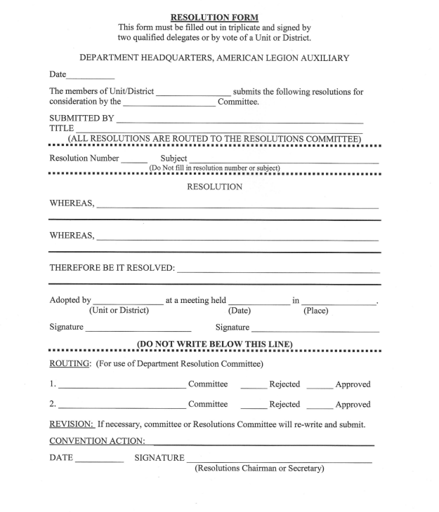

RULES COVERING RECOMMENDATIONS
1. Recommendation format may not be used for changes and/or amendments to the Constitution and Bylaws. The resolution format above must be used. Recommendations are generally more simple and straightforward and do not require the detail of a resolution and usually are used for changes in procedures, not policy.
2. Any recommendation involving the expenditure or appropriation of monies shall be referred to the Department Finance Committee before being considered. The Department Finance Committee shall act upon the recommendation and mark its action on the recommendation. The Finance Chairman will attest by signature. It shall then be returned to the Committee of origin for its consideration.
3. Recommendations usually originate in a committee; however, they may also come from the Department Executive Committee, Units, Districts or individuals and must be presented in writing. All recommendations not originating in committee will be referred to the appropriate committee for action and presentation to the Convention body.
4. Any committee may amend recommendations before favorably reporting same. All recommendations rejected by a committee shall be marked "Rejected” and signed by the chairman.
5. Each Chairman shall report on ALL recommendations made to or by their committee, indicating those which were passed for recommendation to the Convention body, and also indicating those which were rejected. In this manner, the sponsor of a recommendation has an opportunity to speak. In addition, the sponsors will know their recommendations were received and considered.
6. All recommendations passed at a meeting of the Department Executive Committee should go directly to the Chairperson of the appropriate committee, for information and guidance. Executive Committee action is to be presented to the delegates in Convention for consideration.
7. All recommendations presented from a committee shall be presented to the Convention body. Please have copies of the recommendations to hand to the Department Secretary/Treasurer and the Steno typist. 8. Recommendations do not go to the Resolutions Committee for review. The affected committee has sole jurisdiction for review and presentation

Resolutions Chairperson
Miranda Jones
5425 Maybe Road
Clarkston, MI 48346
Vampire21806@yahoo.cocm
(540) 760-8549

