American Legion Auxiliary Department of Michigan

Membership Guide

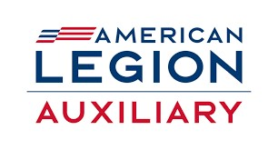

Horse Racing Membership
Shylynn Jones

Department Membership Chairperson
2023-2024

Racing for Membership 2023-2024
Welcome to a captivating membership year in the American Legion Auxiliary. Our President, Kim Champion has always been completely committed to our organization and “Service not Self.” This year, through her “Be a Champion for our Veterans with PTSD” theme, your service to our Veterans, Military families, Community and Children and Youth will be heard throughout Michigan with the xxxxxxxx.

The Membership theme is “Horse Race in Membership.” Each District has been given a unique horse to energize members while working the Mission

Be creative while “horse race in membership” in your Units. Telephone those members who have not renewed, keep in touch with those who you haven’t seen in a while & invite them back, do you have a bell behind the bar, use it to announce new members and the Unit accomplishments. Have fun with it! While respecting each other and working as a team, each member in the Department of Michigan is the most important part of membership.

Department President The Champion
Department Membership Chairperson Pit Boss
Area Membership Chairperson Bookies
Department Officers Trainers
District President Leaders of the pack
Honorary Department Junior President Star Fire (Pretty Ponies)
Department Juniors Pretty Ponies
Auxiliary Members Derby Runners
New Members Foals
Department Commander Champion Horseman
Legion Members Jockeys
S.A.L. Commander Commentator
S.A.L. Members Announcers
Goose Egg Units Pooper Scooper Upper

Have Fun – Race to Win for Veterans!

Shylynn Jones
Department Membership Chairperson

Key Program Statements:
- The role of the Membership Chairperson is to encourage and support the nationwide effort to attract and retain a diverse, active membership and assist units with new members and retaining membership of our current members to ensure the future of the American Legion Auxiliary.

- By honoring our veterans and military through meaningful service, the American Legion Auxiliary will grow our membership. We must let members know that they are the Auxiliary’s most valuable asset.
- There are several things members can do to promote membership for the American Legion Auxiliary including enhancing the member experience, reaching out to former and expired members, attracting new members, and understanding and respecting member rights.

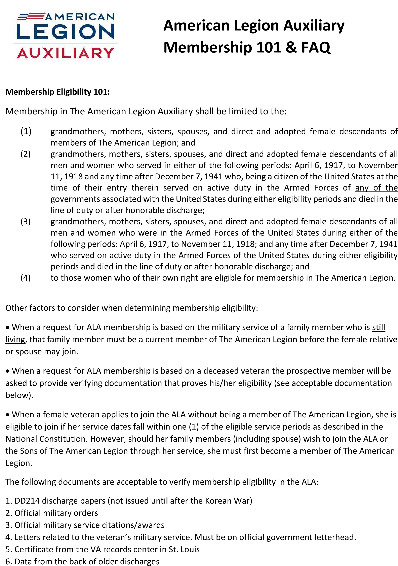

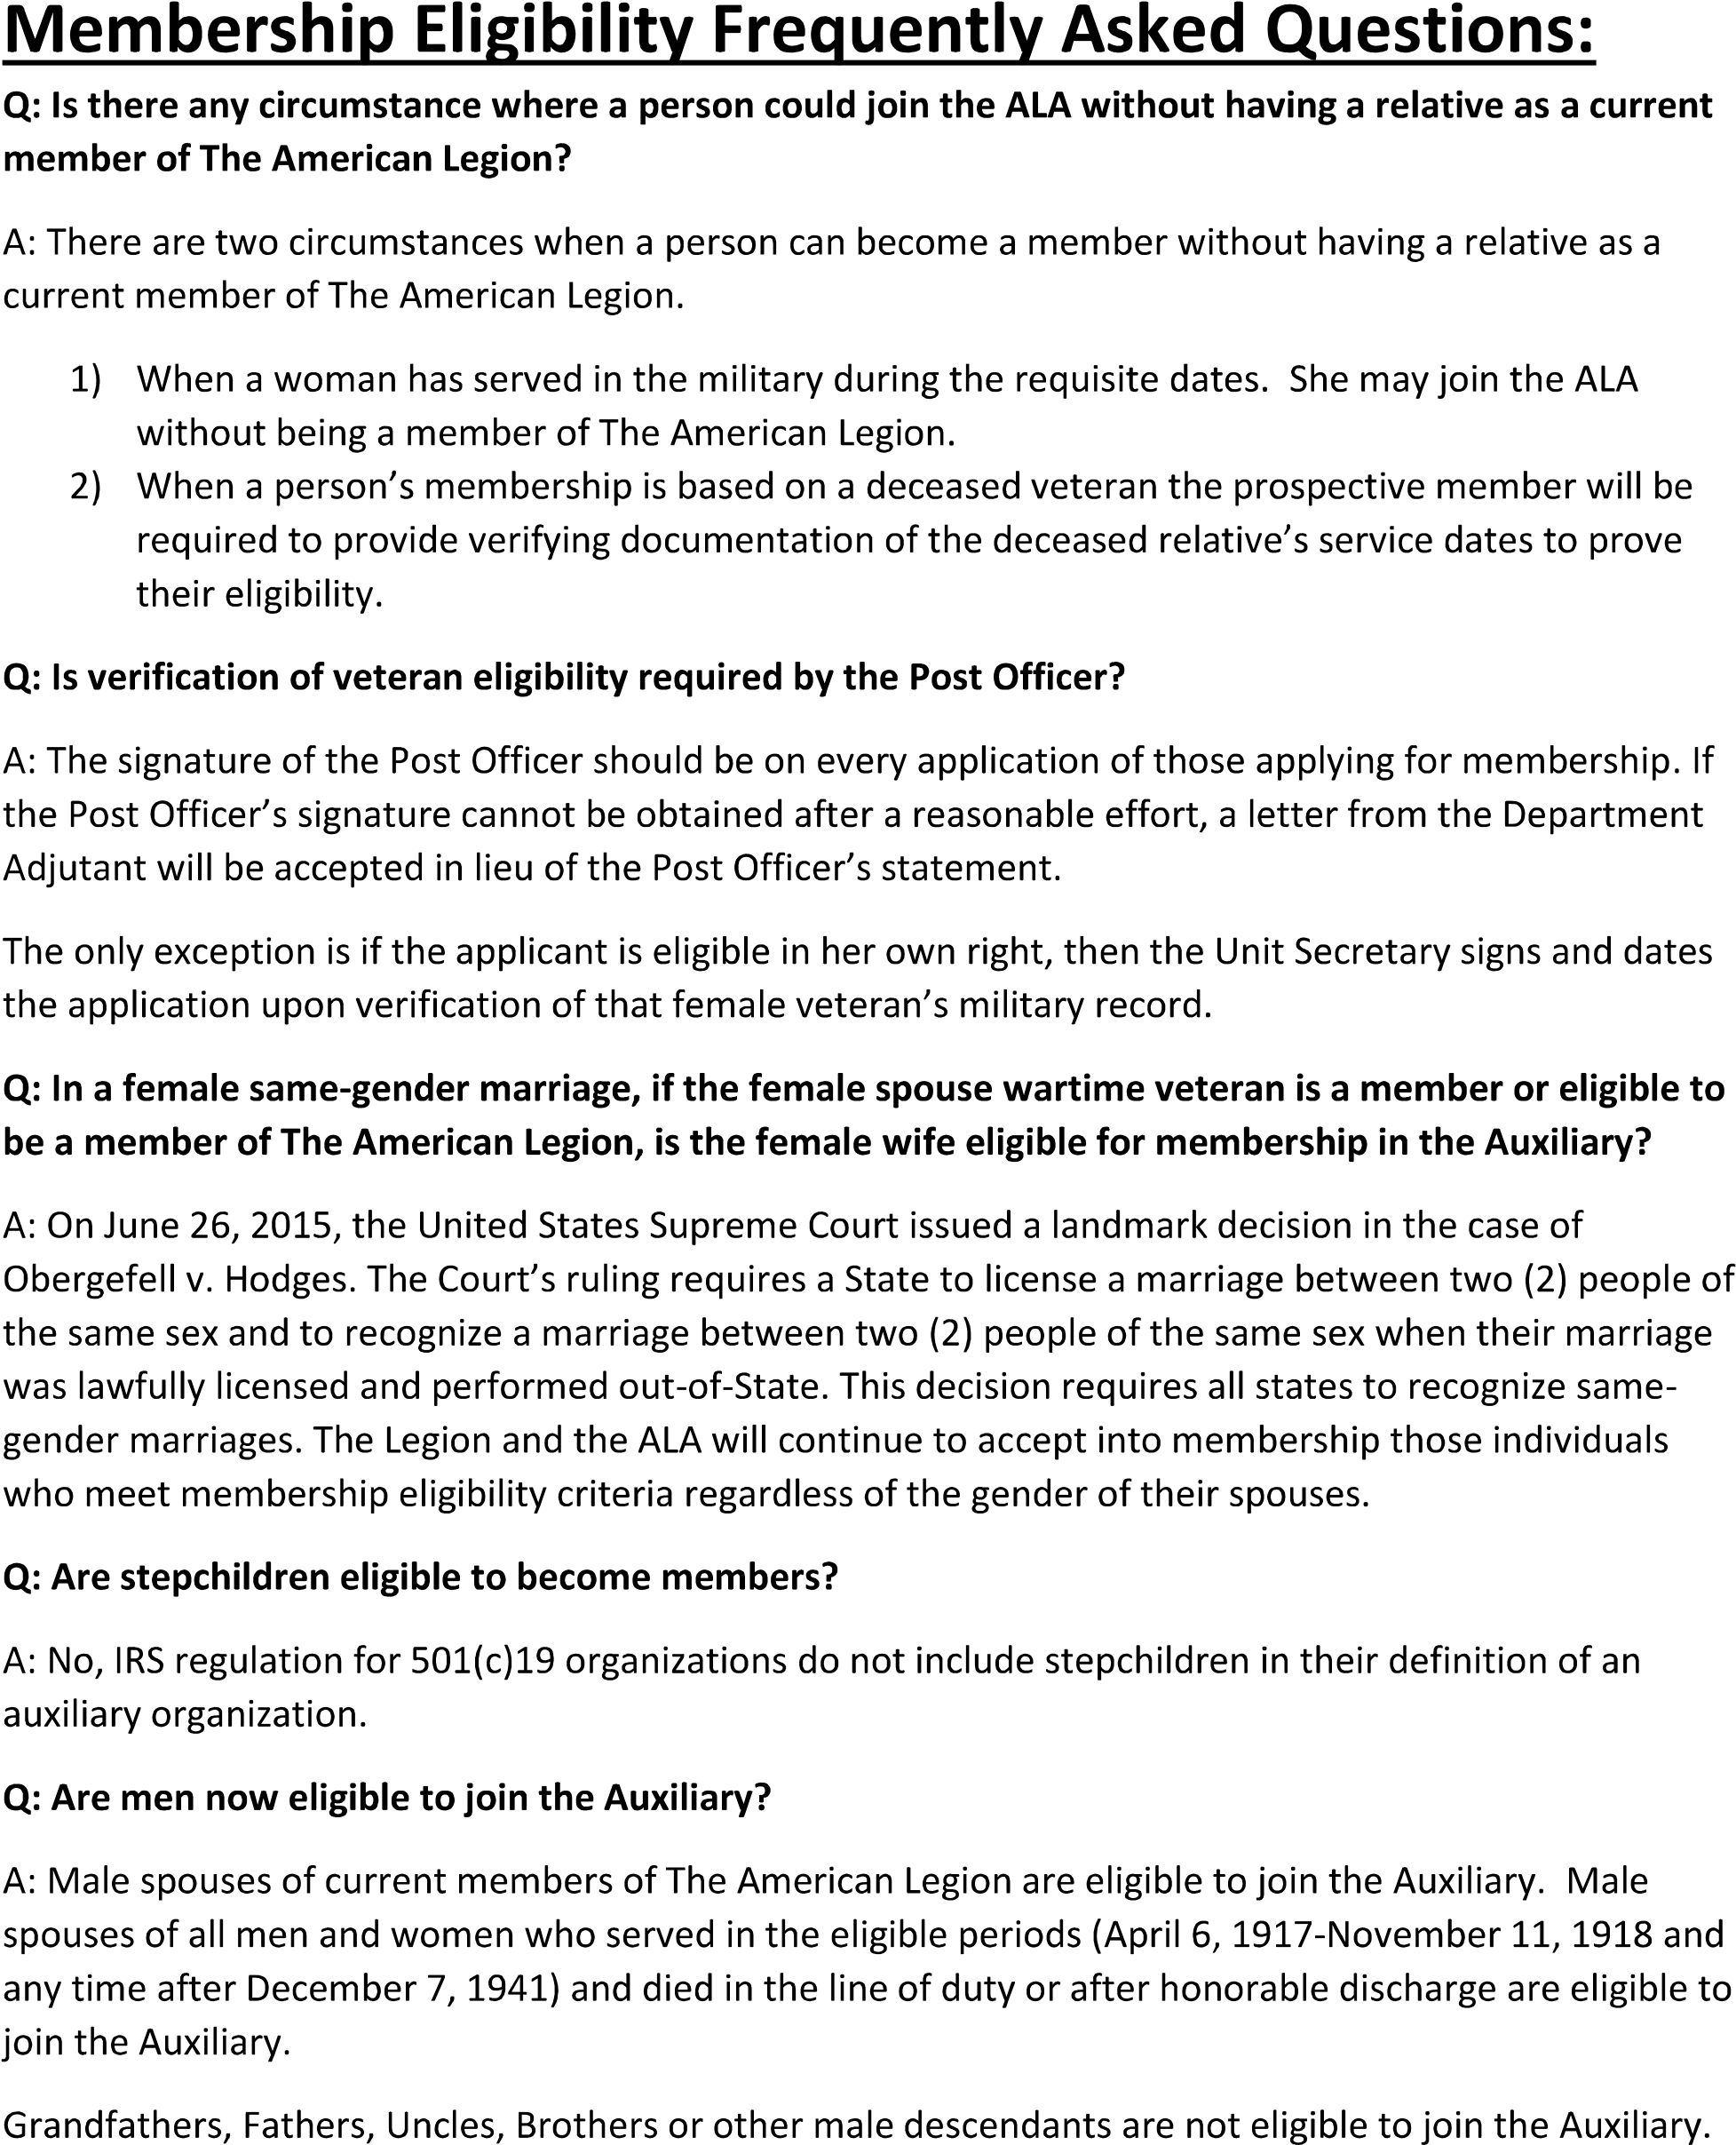

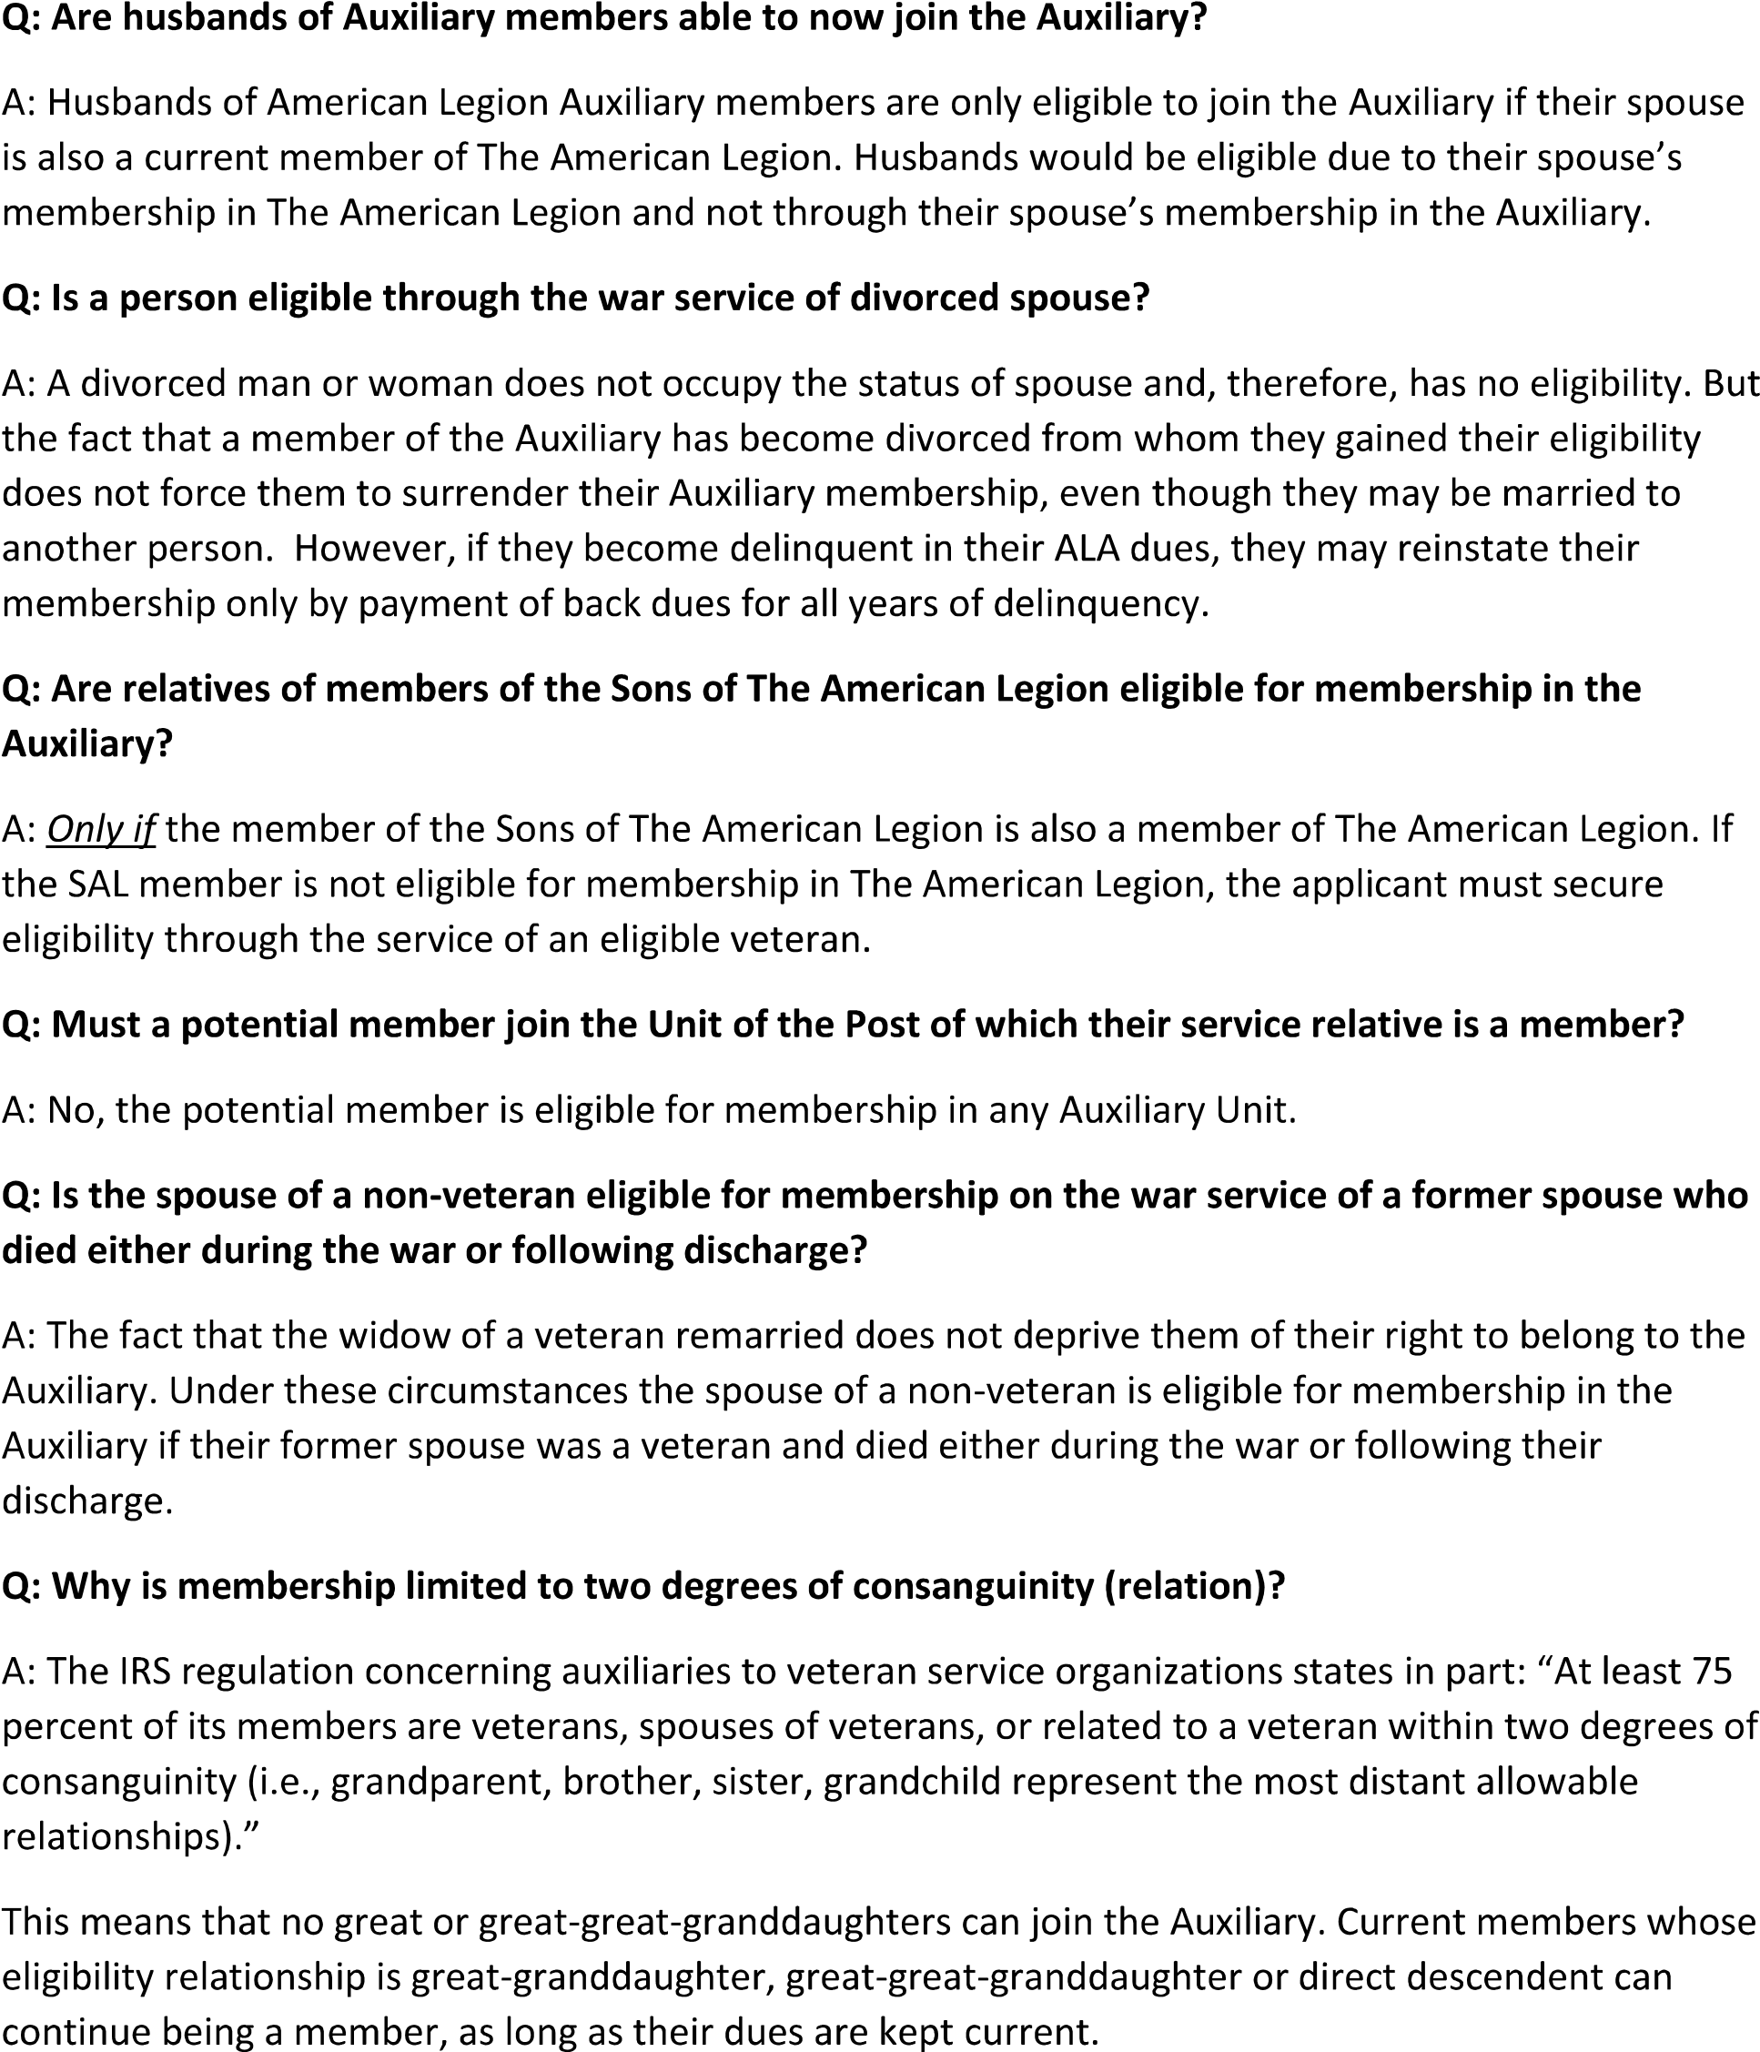

Authorized Forms of Membership

The only authorized form of membership is active membership, of which there are two (2) classes: Senior and Junior. Granting special or honorary membership for any purpose or reason whatsoever is prohibited.
Senior members are those who are age eighteen (18) or older and those under the age of eighteen (18) years and married.
Junior members are those under the age of eighteen (18) years; their activities are supervised by Senior members. Upon reaching eighteen (18) years of age, Junior members are automatically admitted into Senior membership with full privileges. Junior members conduct their own meetings and perform their own special activities, planning their own community service projects and supporting unit projects. Junior members may hold honorary national officer positions. These young volunteers follow in the footsteps of Senior ALA members by donating thousands of hours in service to our veterans.
Once accepted as ALA members, they may continue their membership from year to year, whether or not their veteran relatives continue membership in The American Legion. The fact that a member’s service relative is no longer a member of The American Legion does not compel the ALA member to lose their ALA membership, as long as they do not have a lapse in dues payments.
The phrase “died in the line of duty,” applies to all persons who were killed in action, died of wounds or disease, were killed by accident or otherwise came to their death other than as a result of their own misconduct. In case of doubt, the Adjutant General of the Army, or the Navy Department, Washington, D.C., can advise if the person was considered to have died in the line of duty.
Any person who legally marries a member of The American Legion at any time is eligible for membership in the ALA. A man or woman who is the legal spouse of a male or female Legionnaire is eligible for membership in the ALA.
Widows from legal marriages are also considered spouses for membership.
Applications for membership must be completed for every applicant, and they must provide proof of their eligibility.
Paid Up For Life membership (PUFL): Any member in good standing whose membership dues are paid for the current year may become a PUFL member.
Honorary Life Memberships: This distinction was created for units that confer Honorary Life Membership on outstanding members.

Member Recruitment & Retention
Recruiting and retaining a diverse, active membership is critical to our mission. Well into the future, veterans will need our support and advocacy to assist them at home and abroad, during war and peacetime, to receive the attention and support they deserve.
To ensure the American Legion Auxiliary continues to exist for a future of serving our veterans, military, and their families, our goal is to enhance membership strength. Following is a sampling of the resources available on the MyAuxiliary portal of the national website at www.ALAforVeterans.org to assist in achieving this goal:
- The American Legion Family Membership Brochure
- Paid Up for Life Application
- Unit Guide
- Door Hanger Templates
- Volunteer Interest Form
- ALAMIS Training Manuals
- Membership Award Forms
It is important for department officers, board members and other leaders to become familiar with the tools available as units work to increase the ALA’s positive visibility to attract and retain members. Letting members know that their contributions are valued, along with welcoming, respectful treatment goes a long way toward creating a positive experience and an appealing environment for both current and potential members. Department officers are encouraged to mentor unit leadership with these ideals.

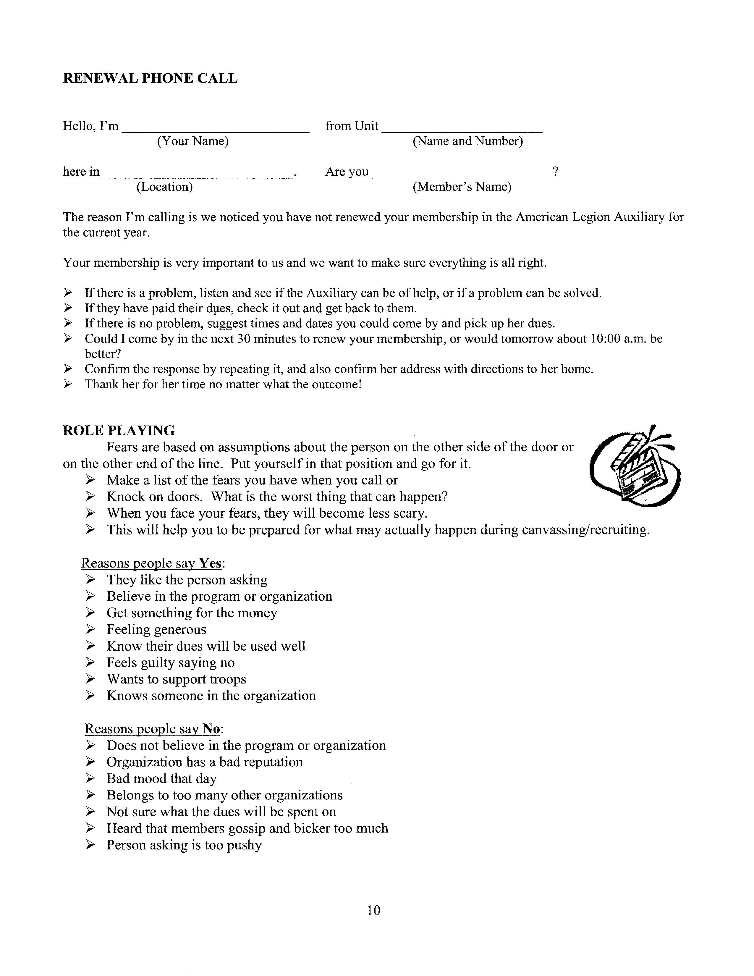
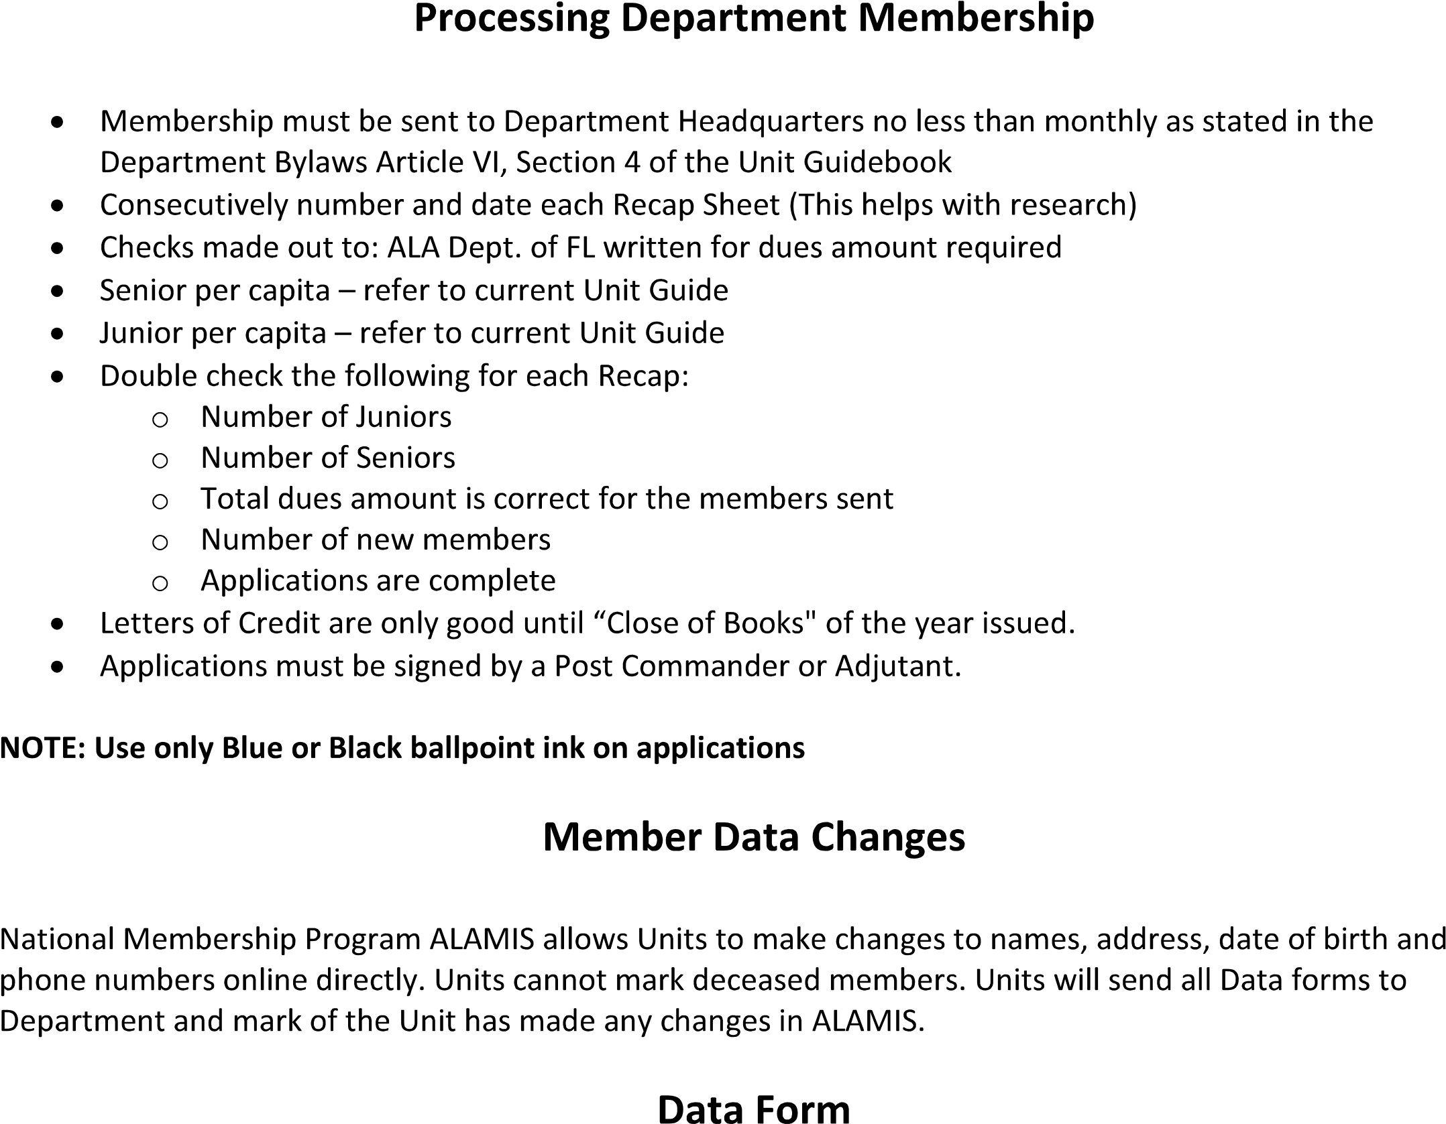
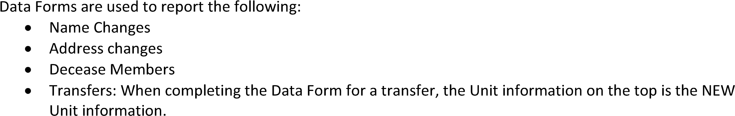
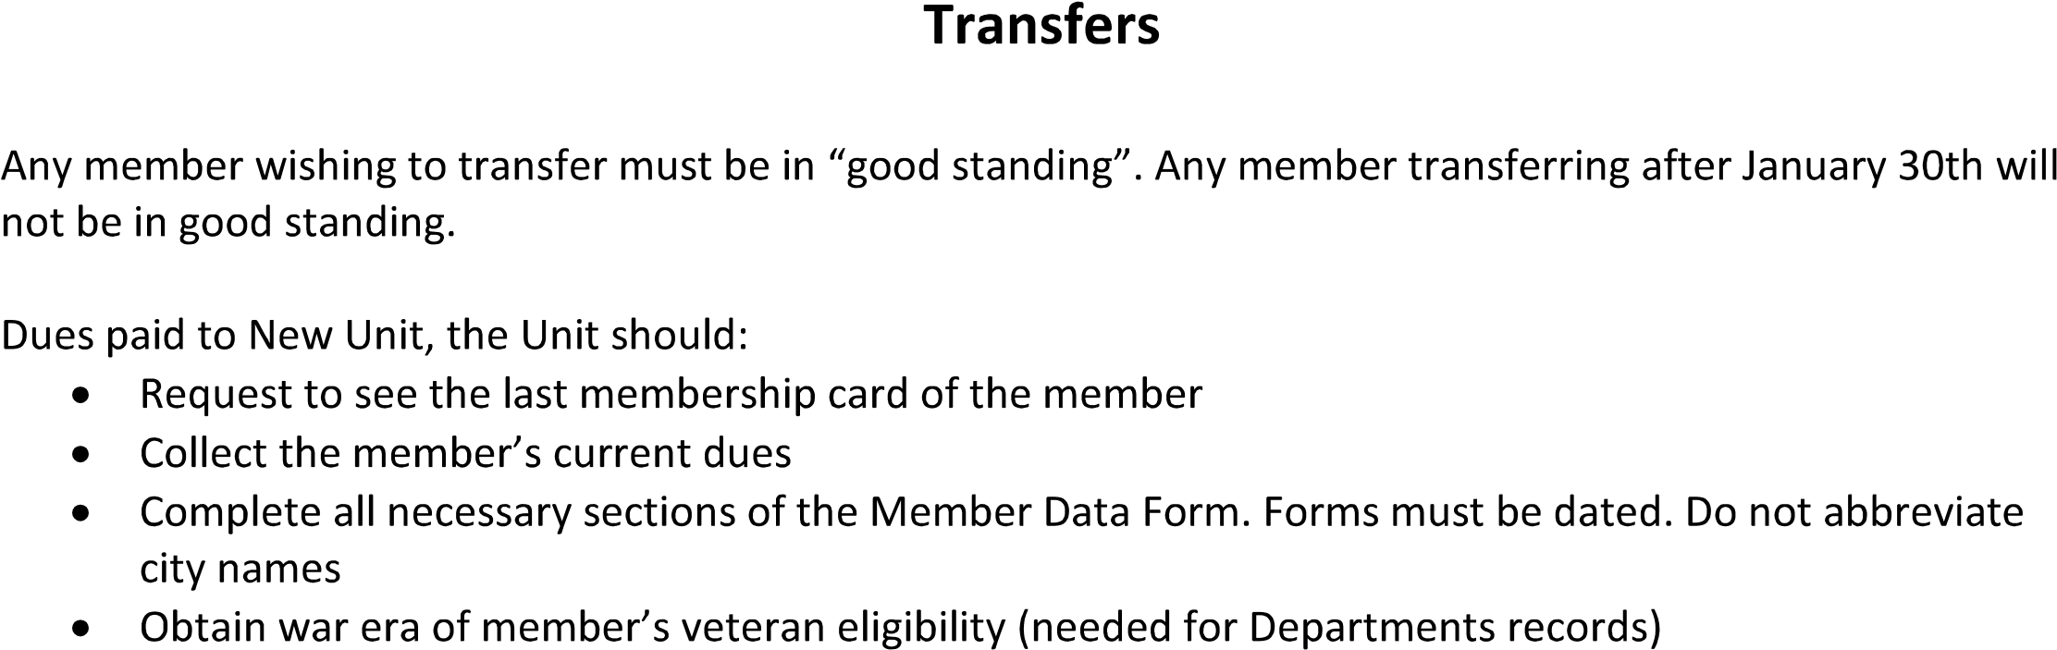
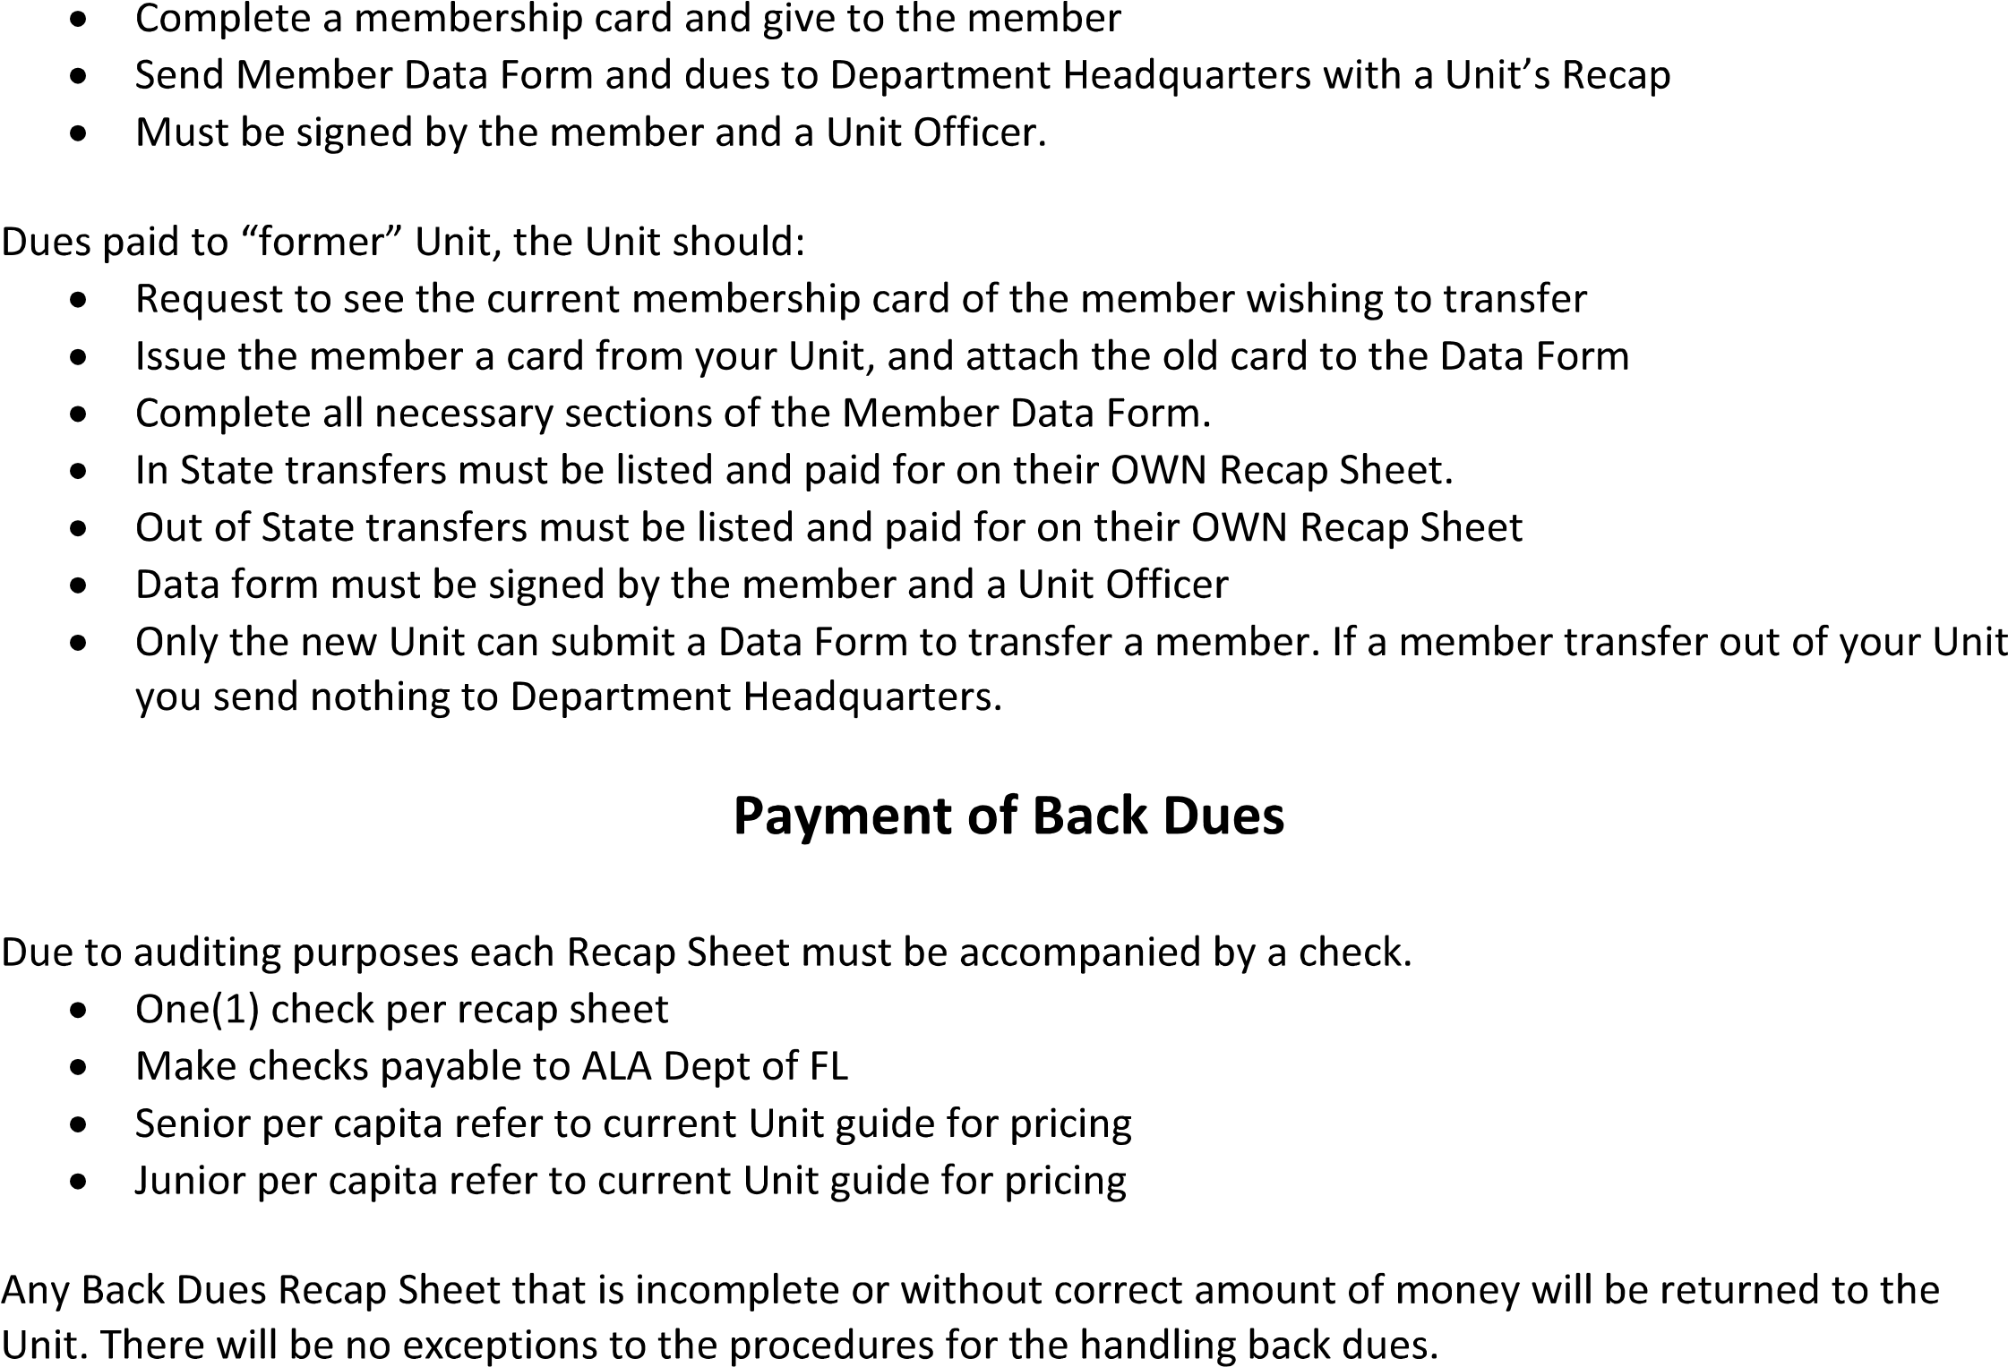
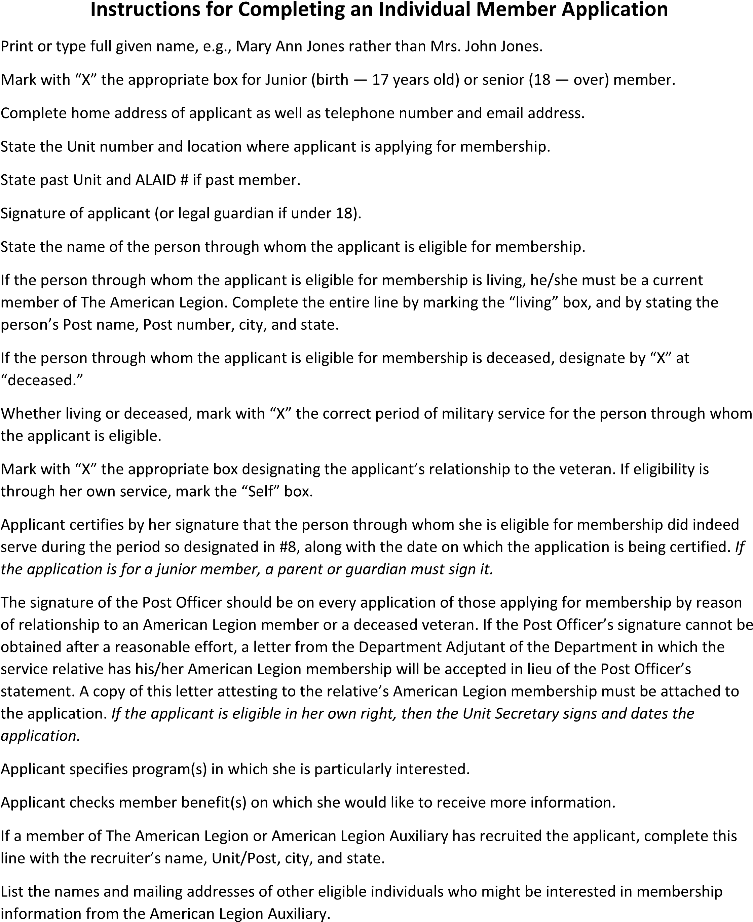
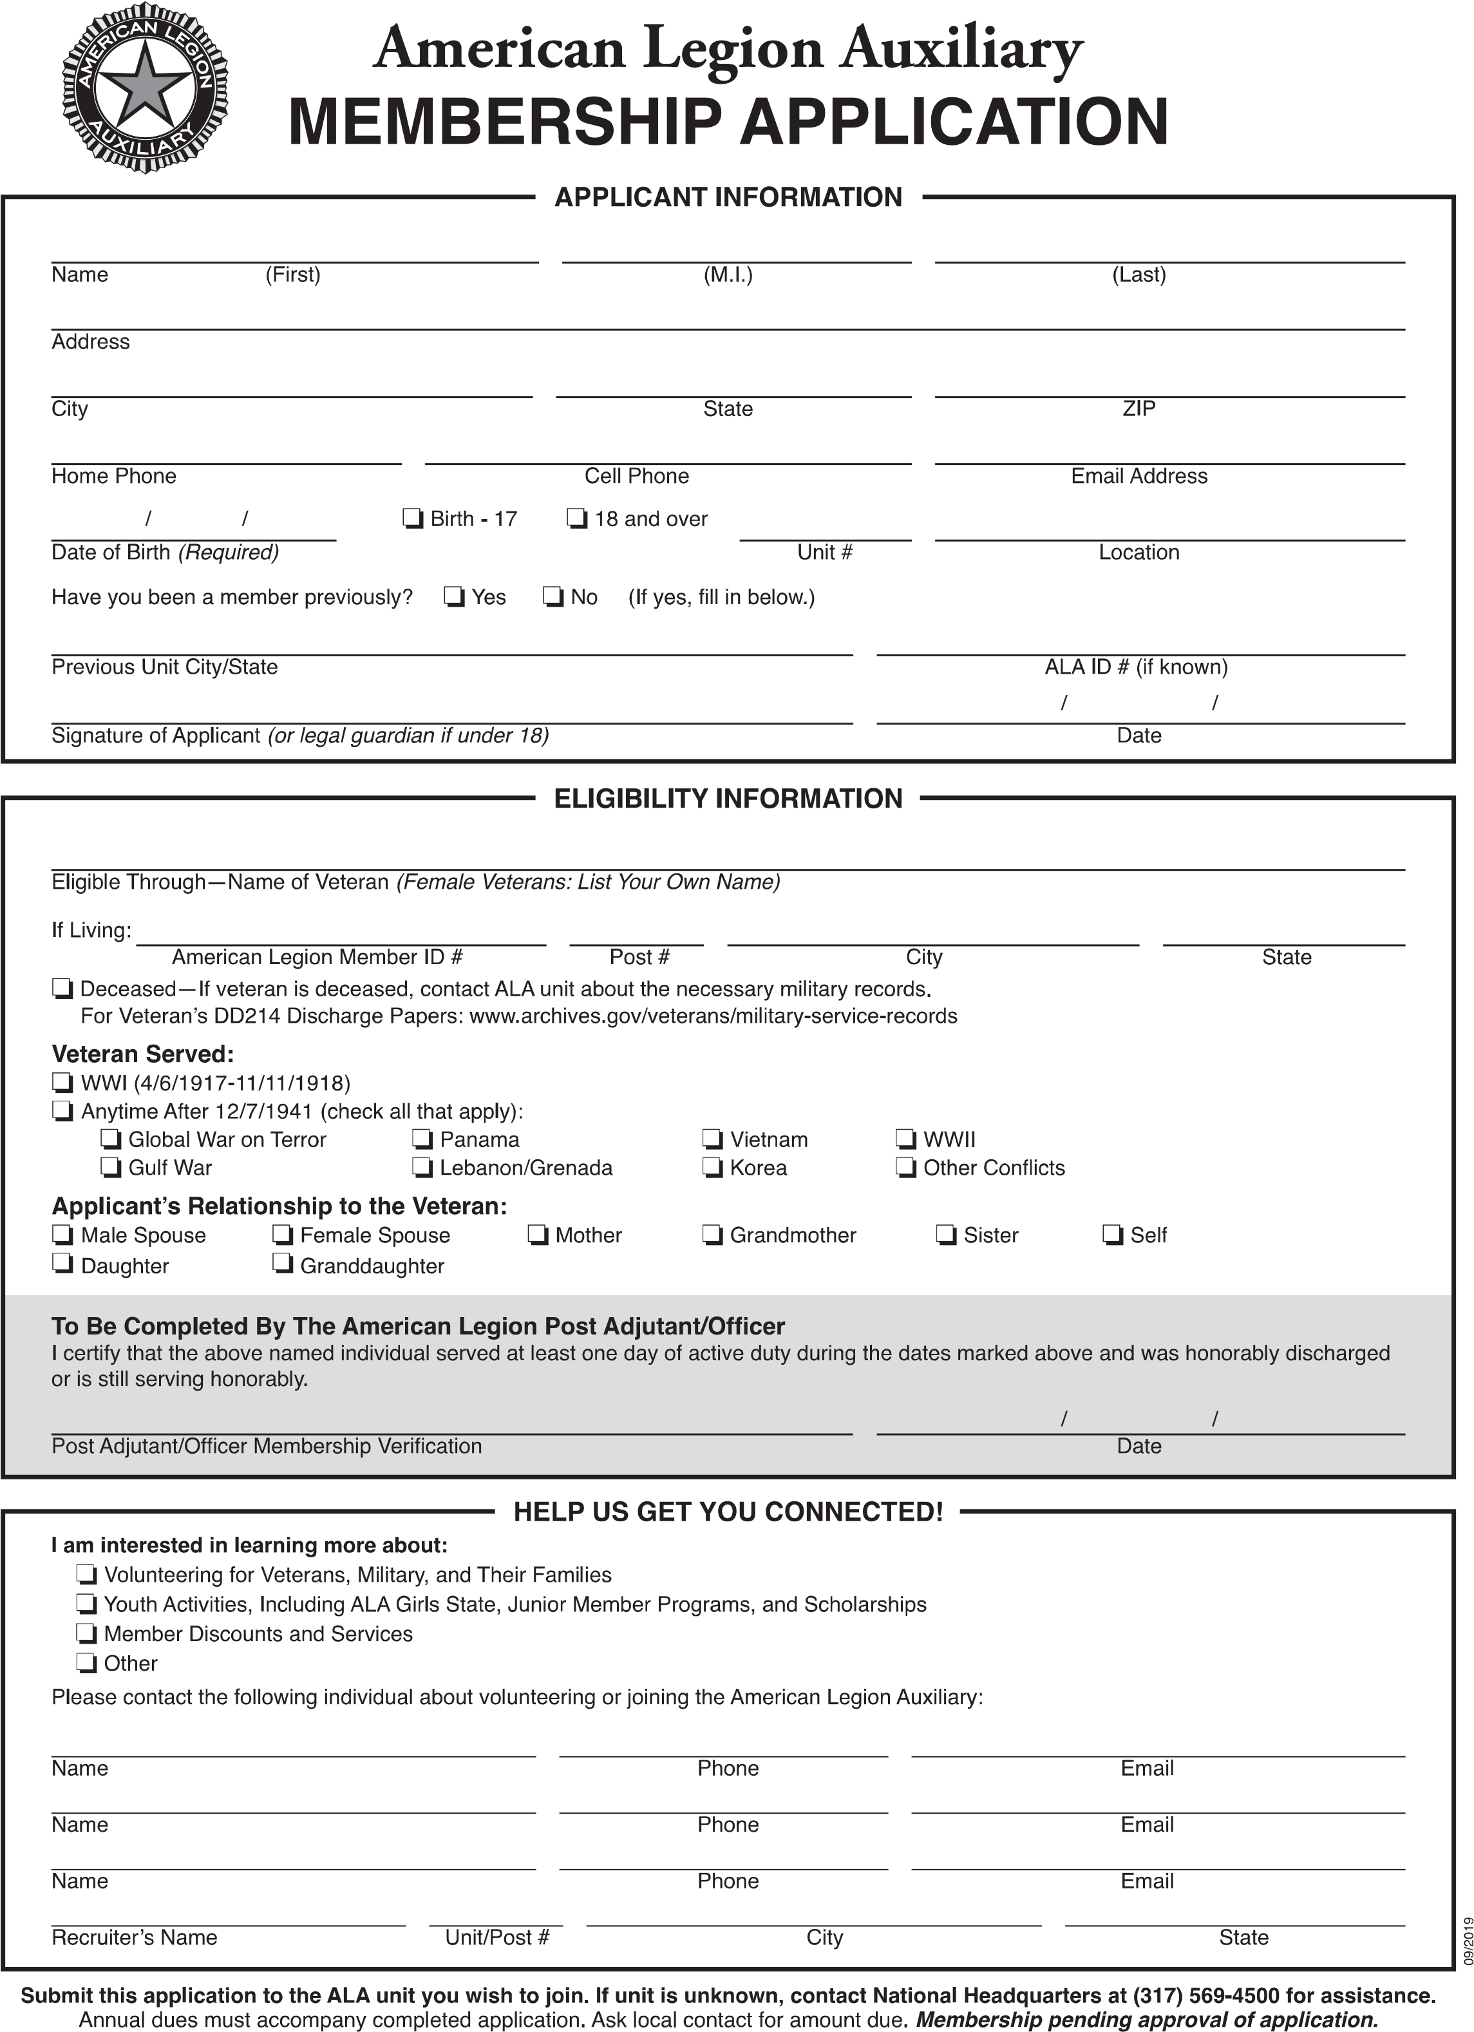
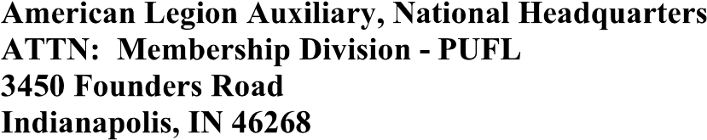
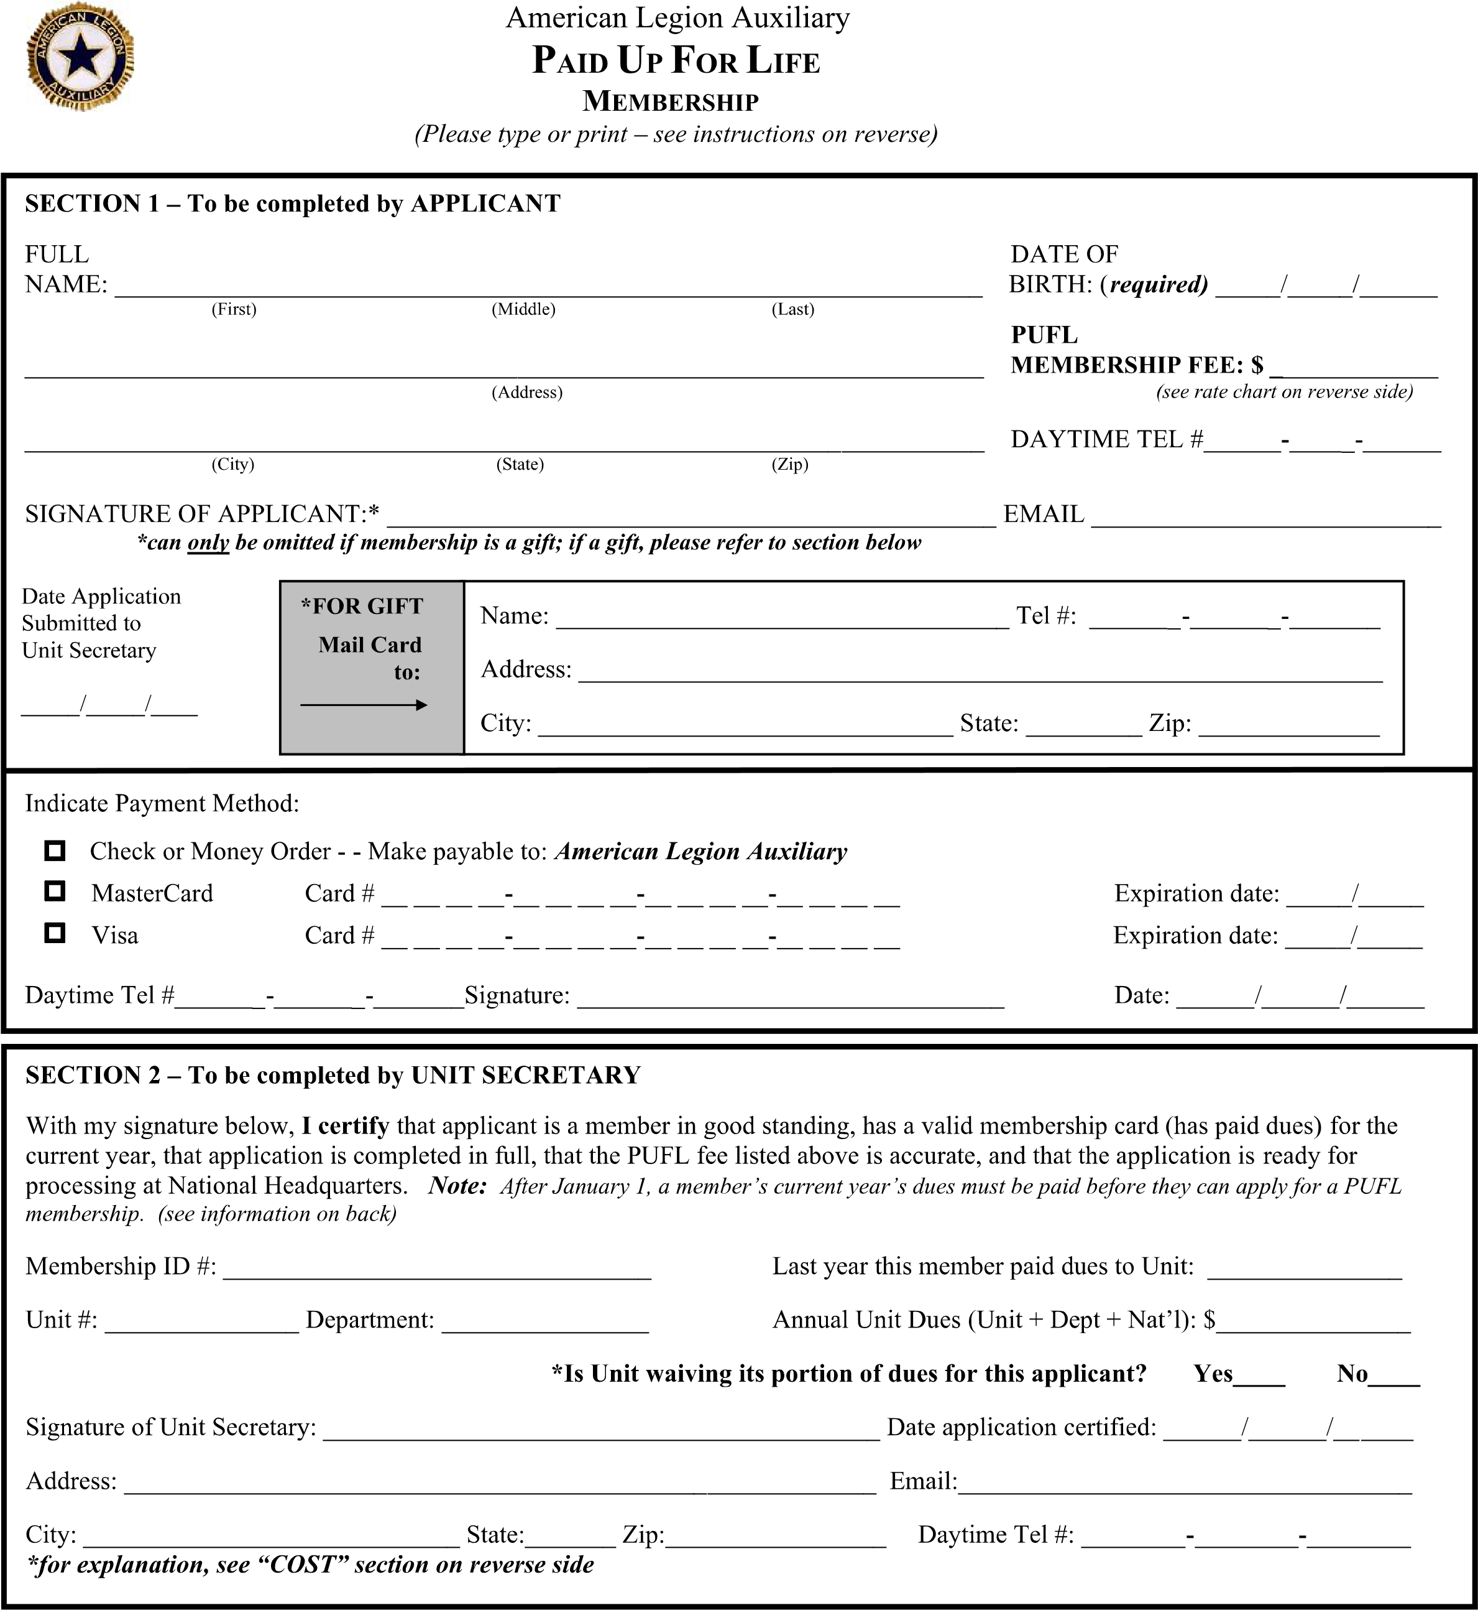
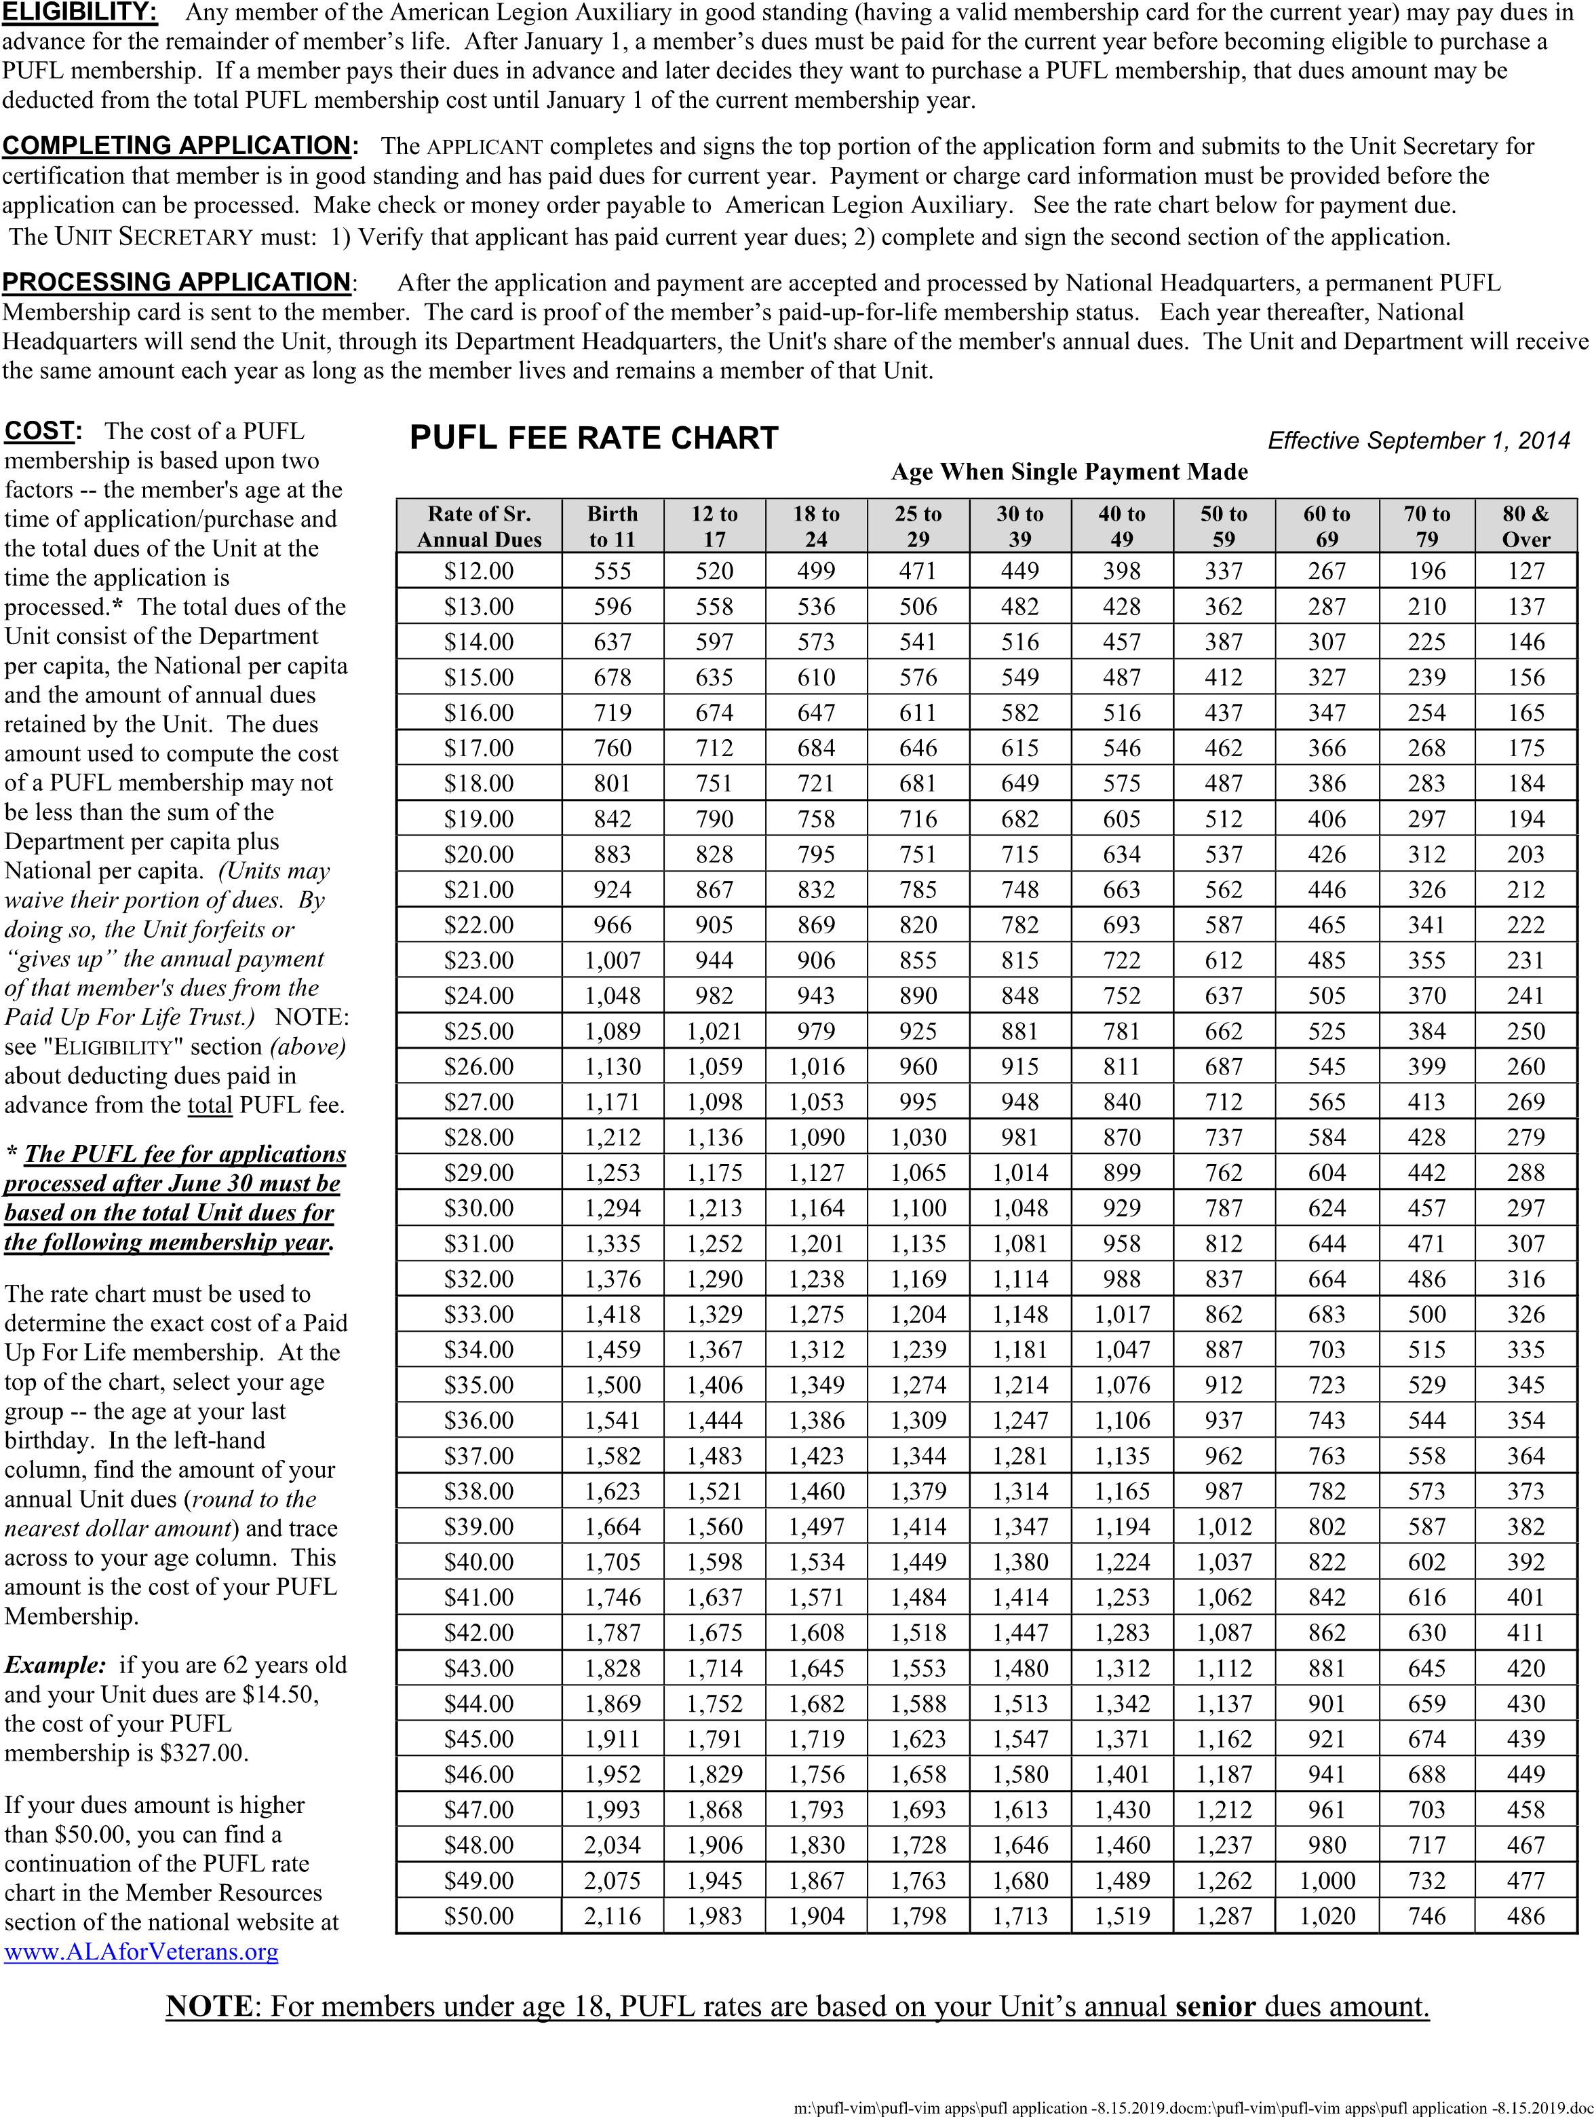

STEP BY STEP INSTRUCTIONS NECESSARY TO COMPLETE MEMBERSHIP TRANSMITTAL
- At the beginning of each new membership year, start over and number each transmittal consecutively starting with the number 1, 2, 3 etc.
- Indicate the year that you are submitting dues for, make sure to submit a separate transmittal for each year you are paying dues on. Please keep the pink copy set for 2019 and the yellow set for previous years for your records.
- Always make sure to date the transmittal the date it was mailed.
- Your Unit name.
- The District number for dues being submitted.
- The Unit number for dues being submitted
- Enter the total number of Junior or Senior renewals; Junior or Senior new; Rejoins and transfers. Multiply this number by the dues rate preprinted on the form to the right. Do NOT send payment for members who paid Online! Those funds are sent to Department from National. Department will either send a check or credit memo to you when we receive Online dues and PUFL payments.
- Enter the total dollar amount.
- Enter the total of members to pay in this column.
- Enter total dues for these members. IT IS VERY IMPORTANT TO DOUBLE CHECK YOUR
MATH, MEMBER COUNTS, AND MAKE SURE THAT THE CORRECT AMOUNT HAS BEEN ENTERED AND THAT IT MATCHES THE AMOUNT OF THE CHECK SUBMITTED 11) If you are using a credit on this transmittal subtract the amount of the credit.
- If you are paying a previously owed debit ADD the amount to the transmittal total.
- Notate the check number(s) that corresponds with this form. If you are submitting more than one year or multiple transmittals you may total all transmittals and submit one check. Please indicate the transmittal numbers being paid on your check.
- Enter the total amount of the check being submitted.
- Print the name of the person completing the transmittal and sign. We need this information so we may contact you.
Revised 6/2022
Send the white copy with the check for the total dues PLUS a Transmittal List of Members in alphabetical order of the names you are submitting with the form. Also include the member ID#’s, whether the member is a Junior or Senior, a New, Renew, Rejoin, and if they Joined/ Renewed Online.
Please be sure to make sure any new member applications are fully completed. See separate instruction guide.
It is the responsibility of the Membership Chairperson of each Unit to check the Membership Report online at our website (www.michalaux.org) monthly to make sure the Unit’s numbers match those Department is reporting.
HOWEVER, IT IS RECOMMENDED THAT YOU WAIT A PERIOD OF AT LEAST TWO WEEKS AFTER THE TRANSMITTAL WAS MAILED. This will allow for processing.
Please be sure to send Department all originals of paperwork. Make and keep copies of everything prior to submitting to Department. This is helpful for you to keep accurate records or in the event paperwork is lost in the mail, etc.
Special Note – Department does NOT want or need DD-214’s or other personal records that are used to support membership eligibility. Once the Post Commander or Adjutant reviews the paperwork for accuracy their signature serves as proof all eligibility requirements have been met.
Department reserves the right to return Membership Transmittals and other submissions to the unit if they are not compete or submitted improperly.
PROCESSING OF MEMBERSHIP IS AN IMPORTANT AND VITAL ROLE OF EACH UNIT, WE WANT TO SAY THANK YOU IN ADVANCE FOR TAKING THE TIME AND EFFORT FOR REPORTING AND TRANSMITTING YOUR MEMBERSHIP TO THE DEPARTMENT OFFICE.
If you have any questions prior to submitting membership paperwork please do not hesitate to call Department at (517) 267-8809 or email
membership@michalaux.org
Revised 6/2022
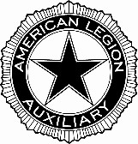
American Legion Auxiliary Department of Michigan
212 N. Verlinden Ave, Ste. B • Lansing, Michigan 48915
517-267-8809 • www.michalaux.org
_____________________________________________________________________________________

UNIT TRANSMITTAL FORM
For 2024 Membership Year or Later

THIS FORM MUST ACCOMPANY ALL MEMBERSHIP DUES

Transmittal #: ___________ Membership Year: _____________ Date: ____________________

Unit Name: __________________________________ District #:__________ Unit #: _________

TOTAL JUNIORS: | Renewals | ______ @ $ 4.25 each = $____________
TOTAL JUNIORS: | NEW** | ______ @ $ 4.25 each = $____________
TOTAL SENIORS: | Renewals | ______ @ $31.50 each = $____________
TOTAL SENIORS: | Rejoins | ______ @ $31.50 each = $____________
TOTAL SENIORS: | Transfers | ______ @ $31.50 each = $____________
TOTAL SENIORS: | NEW** | ______ @ $31.50 each = $____________
TOTAL JUNIORS & SENIORS: ______ TOTAL $____________
LESS ANY CREDITS BEING USED -____________
ADD ANY DEBITS BEING PAID +____________ ENCLOSED CHECK NUMBER _________ IN THE AMOUNT OF $____________
**Please make certain that all membership applications are verified with a signature of an authorized member of the American Legion Post. Do not forget to write your Unit No. on the application.
 | Please PRINT All Information Clearly!
Please double check Unit records, the current  Unit roster and previous transmittals to be sure the following members are not being paid: PUFL’s, members who paid online, members who were already paid on a previous transmittal. Incorrect transmittals will be _{returned.}  Send this form to Department with dues payment and a list of members you are submitting payment for. The list must be in ALPHABETICAL order.  WHITE COPY: Department  PINK COPY: Unit Files | Print Name:_________________________________  Title: ______________________________________  Mail Address: _______________________________  City, State, Zip:______________________________  Phone: ____________________________________  Email Address:______________________________  Signature: __________________________________

Revised 6.20.2023

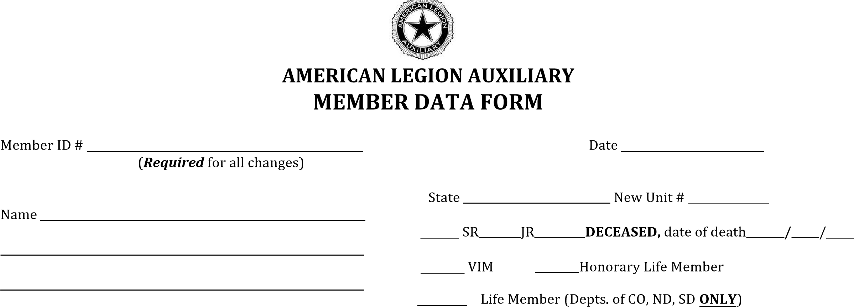
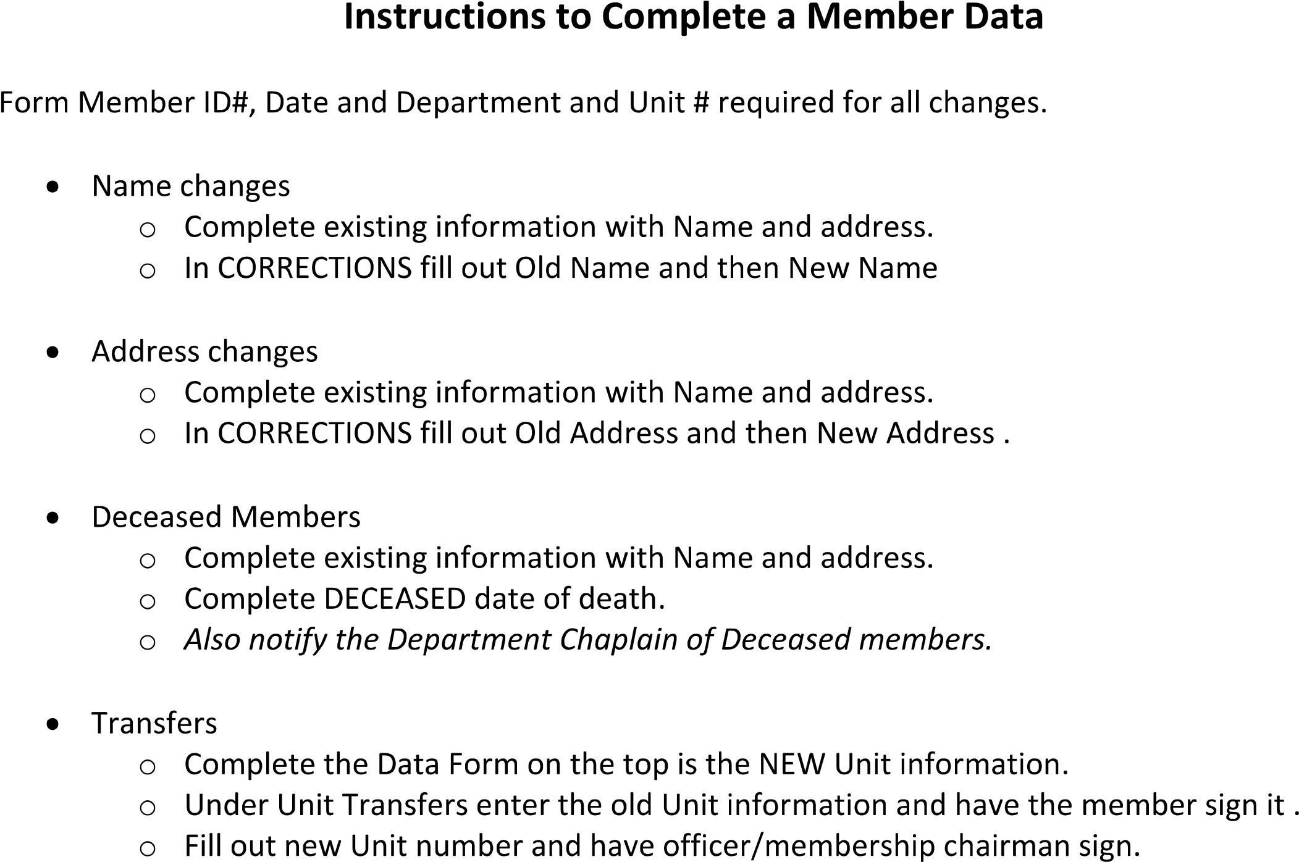
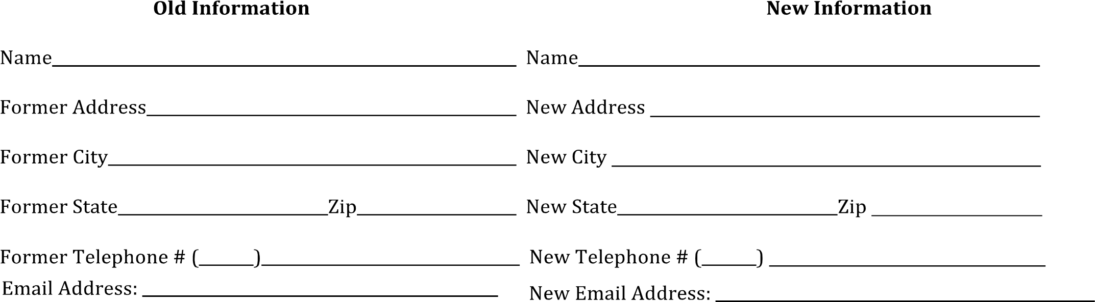

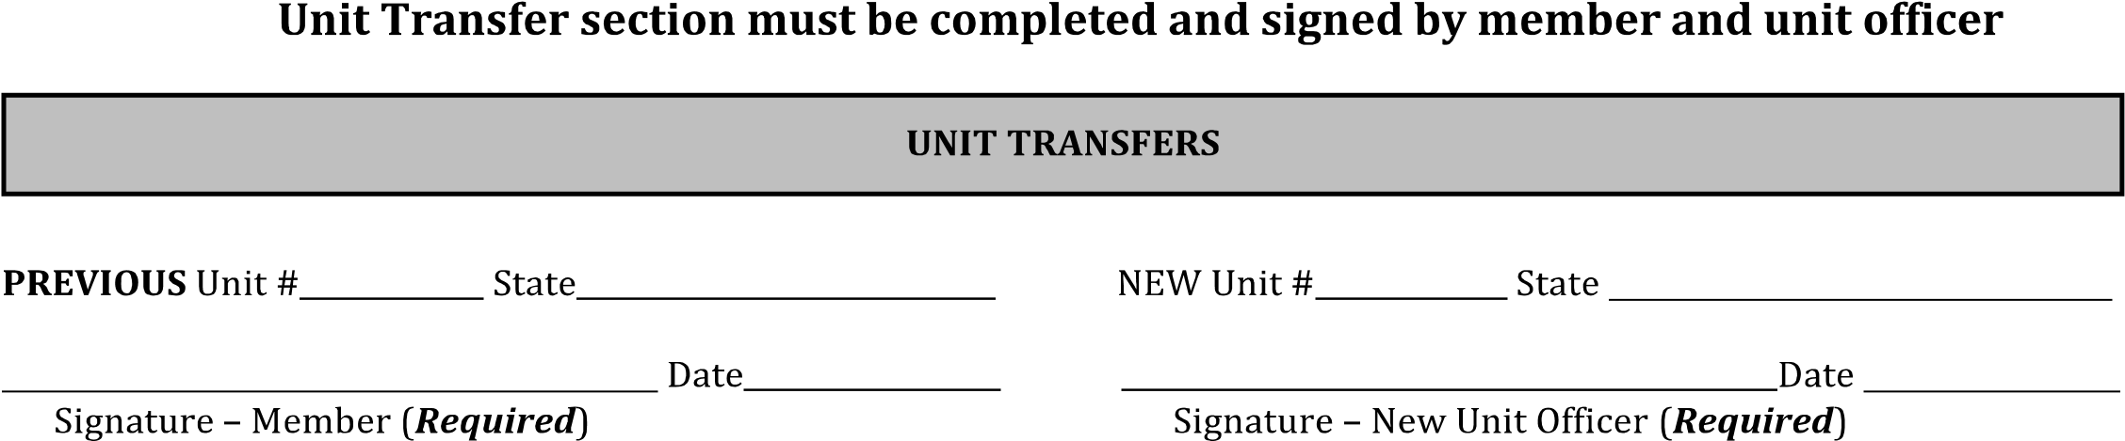
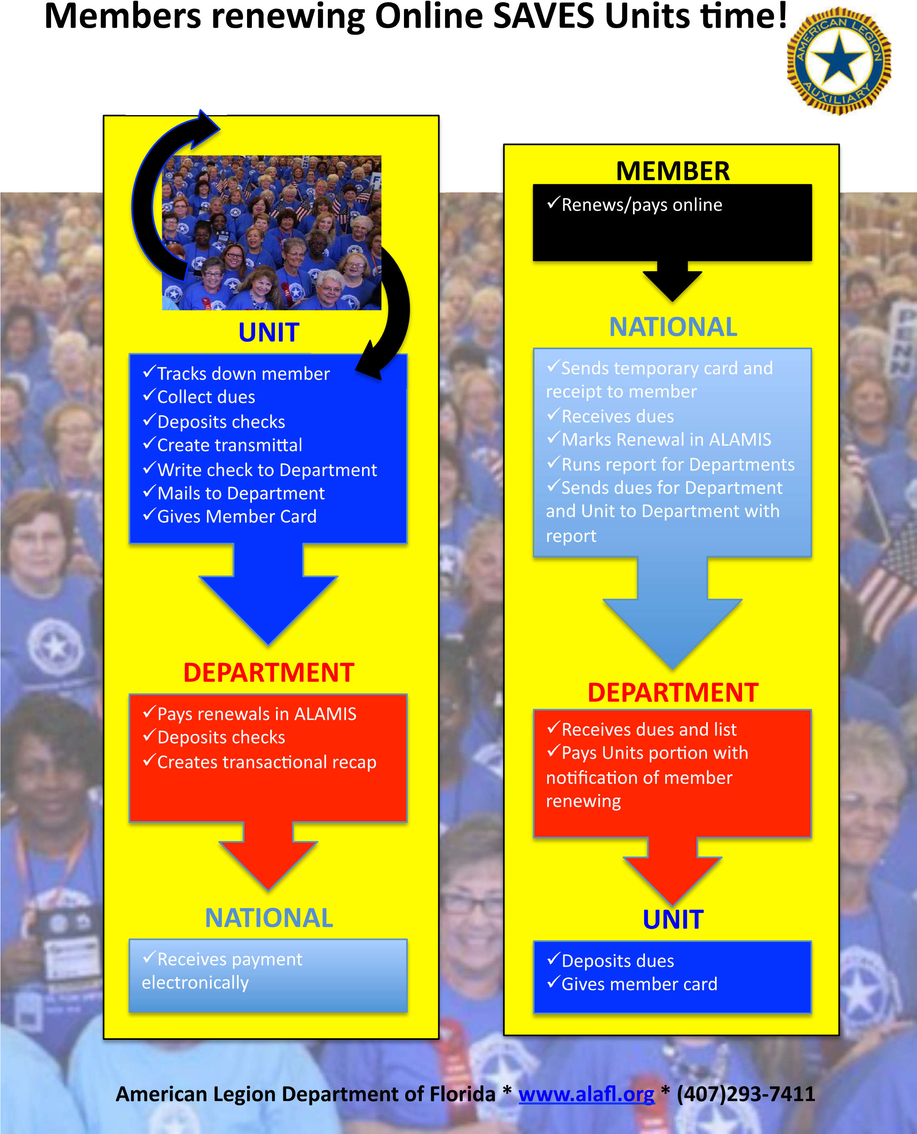

DEPARTMENT MEMBERSHIP COMMITTEE
2023-2024

DEPARTMENT CHAIRPERSON
Shylynn Jones
5425 Maybe Road
Clarkston, MI 48346
C 540-656-3373 raven14378@gmail.com

AREA MEMBERSHIP CHAIRPERSON
WESTERN AREA CHAIR |  | EASTERN AREA CHAIR
Districts 3, 4, & 5  Kathie Hartman-Gleasson |  | Districts 6, 7, 8, & 18  Barb Stutesman
limissemma@sbcglobal.net |  | bstutz@comcast.net
402 Days Rd. |  | 508 Dunleavy Drive
Buchanan, MI 49107 |  | Highland, MI 48356
574-340-0361 |  | 248-701-2177
UPPA AREA CHAIR |  | SOUTHERN AREA CHAIR
Districts 12 |  | District 1, 2, &16
Bonnie Taylor |  | Donna Price
btaylorvasqyez@yahoo.com |  | Kitten9042@aol.com
609 Kennedy Road |  | 1559 Garfield Ave
Iron Mountain, MI 49801 |  | Lincoln Park, MI 48146
906-259-1408 |  | 313-388-6192
LOWER NOTHERN AREA CHAIR
District 9, 10, & 19
Charly Mathews
charlyscandles@yahoo.com
5415 S. Sastephan Bridge Rd
Grayling, MI 49738
989-529-8396

District and County Map
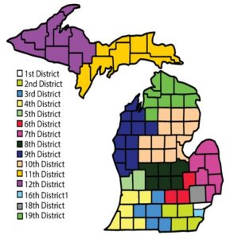
Southern Area: Districts 1 & 16
Eastern Area: Districts 6, 7, 8, 17, & 18
Western Area: Districts 2, 3, 4, & 5
Lower Northern Area: Districts 9, 10, & 19
Upper Northern Area: District UPAA

“IMPORTANT DATES”
MEMBERSHIP CELEBRATIONS
2023 – 2024

NATIONAL DUES EMAILS/MAILINGS REMINDERS

July 2023 Email - Renewal Reminder
September 15, 2023 - 1st USPS Renewal Notice
November 2023 – Email Renewal Notice
February 1, 2024 – 2nd USPS Renewal

(Email reminders are only sent to members if there is an email address in ALAMIS)

DEPARTMENT MEMBERSHIP DATES
“Membership Grow”

TARGETS DATE

75% December 7,2023 (Pearl Harbor Day)
85% March 15, 2024 (TAL Birthday)
95% May 24, 2024 (National Poppy Day)
100% July 4, 2024 (Independence Day)
102% July 24, 2024

Membership Awards

The Gladys Taylor Citation
Presented to the Unit with the highest percentage of goal.
Deadline: January 31, 2023.

Doyle Cup
Presented to the Unit having the highest percentage goal
Deadline: April 1, 2023.

Patricia Donald Citation
Presented to the Unit with 200+ Memberships having the greatest numerical increase in Membership
Deadline: 30 days prior to Convention

Chloe O’Neil Cup
Awarded to the Unit having the greatest numerical increase in members.
Deadline: 30 days prior to Department Convention

Esther V. McCoy Cup
Awarded to the Unit having the highest percentage increase over the previous year’s Membership.
Deadline: 30 days prior to Department Convention.

Orlene Penning Citation
Awarded to the Junior Group having the newest members for the year.
Deadline: 30 days prior to Department Convention.

Ethel Stitt Cup
Awarded to the District having the greatest numerical increase in members.
Deadline: 30 days prior to the Department Convention.

Elizabeth Lyons Citation
Awarded to the District Chairman with the highest percentage increase.
Deadline: 30 days prior to Department Convention.

All Units that reach their goal by June 6, 2024 will be awarded ribbons.

