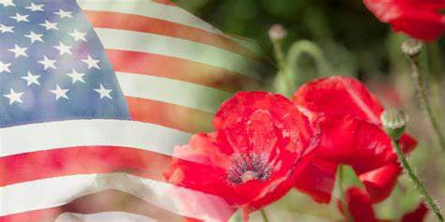

**Department of Michigan Poppy Program Plan of Action 2025-2026**

The purpose of the American Legion Auxiliary Poppy Program is to honor & support veterans for their service and sacrifice by promoting and educating all people about the history of the Poppy and the financial benefits realized by our nation’s veterans as a result of its distribution.

**POPPY PROGRAM OBJECTIVES**

**1. Promote/circulate the history of the poppy and the importance of its distribution.** Members can: wear poppies; help distribute poppies and poppy items; learn and share the Poppy Story; participate in the Poppy Poster, Poppy Artistic Creations, and other contests; etc. Units can: order veteran-made ALA poppies from our own Department of Michigan (which helps supplement these veterans’ income. Check w/ Department 1st re: their supplies because poppy makers are down from previous years); order poppy kits from Flag & Emblem Sales and assemble them ourselves or even order from other states if need be; educate members and the general public about the Poppy Story; host Poppy Poster Contests; share how you used your Poppy Funds; deliver poppies to legislators or media; observe National Poppy Day (always the Friday before Memorial Day); request a Poppy Day Proclamation from your mayor; etc.

**2**. **Increase Poppy Revenues** (so we can honor and support) Members can: help distribute poppies and solicit donations where permitted; create different fundraising ideas (i.e., canvas painting experience, casino bus trips, bake sales, etc.); take a can and make a plan; etc. Units can: contact businesses to obtain permission to distribute poppies (and thank them afterwards); offer other poppy items for donation, like pins, bookmarks; host a variety of Poppy Fundraisers, etc.

**3. How Do We Impact?** Members can: report their volunteer hours, monies raised & fundraising ideas; when in public, project a positive image, wear a poppy and/or our ALA logo; bring member applications, etc. Units can: track and report your members’ volunteer hours and efforts; thank and recognize your members’ contributions, whether it is time, money, or ideas; report at the Year-End, so we can collectively convey our impact.

**Program Contests and Awards-Deadline and Requirements Information**

**POPPY POSTER CONTEST**…(for students in 2nd-12th grades, including Special Needs. (Consider donating poster board and art supplies to the teachers for this project.)Units should judge and forward their 1st Place winner (for each Class), onto their District Chairman by **March 31, 2026**. *(Note-verify with your District Poppy Chair for specifics). Districts should send their 1st Place winner (for each Class), accompanied by a Green Slip, to the Department Committee Chair, Christine Merlington, 17259 Pringle St, Sand Lake, MI 49343, by **April 15, 2026**.

1. Poppy Poster Contest Rules Units shall sponsor contests in local schools. When schools do not conduct these activities, other youth groups such as our Juniors, church, scouting, may participate, if supervised by a Unit member. 2. There are seven classes: Department Awards Class I: Grades 2 & 3 Class IV: Grades 8 & 9 1st Place =$50.00 Class II: Grades 4 & 5 Class V: Grades 10 & 11 2nd Place=$25.00 Class III: Grades 6 & 7 Class VI: Grade 12 3rd Place=$15.00 Class VII: Students with special needs are defined as: Those in special education classes, a student recommended for special education classes and not admitted due to waiting list or other factor. A child identified as having a disability, but not in a special education class due to a lack of facilities. 3. Poppy Poster Requirements a. Each poster shall have a fitting slogan not to exceed 10 words. (Articles “a,” “and,” “an,” “the,” will not be counted as words. The words “Buddy” and “buy” cannot be used.) b. The words “American Legion Auxiliary” must be used in the design of the poster and will not be counted in the 10-word count. c. Each poster must include a picture of the red Flanders Field poppy(s). d. The poster shall be on an 11 X 14 poster board. (Drawing paper will not be accepted). e. The United States Flag may be used as long as there are no infractions of the flag code. f. Posters will be judged using the following criteria = **50% -** poster appeal (layout, message, originality), **40%** - artistic ability (design and color), **10%** - neatness. *g.* Media allowed shall be watercolors, crayons, powder or oil paint, handmade paper cutouts, ink or textures, acrylics, pencils, and markers. h. Written in ink on the back of the poster shall be the Class (grade), the student's name, address, age, their grade level, and the name of the Department of Michigan. i. Submissions become the property of the American Legion Auxiliary. (*We recommend participants take a picture or scan their poster for their records. j. The poster shall be the work of only one individual. k. The label “In Memoriam” from the veteran-made poppy may not be used.

**NATIONAL LITTLE MISS POPPY**: Little Miss Poppy (Department Award 1st Place=$50.00) Units should send their 1st Place entry to their District Chairman by **March 31, 2026**. Districts should send their 1st Place entry, accompanied by a Green Slip, to the Department Chair, Christine Merlington, 17259 Pringle St, Sand Lake, MI 49343, by **April 15, 2026**. **RULES**  a. Participant must be between six and twelve years of age and be a Junior member in good standing.  
b. Promotional activity of the Poppy Story must occur through the American Legion, the American Legion Auxiliary, and the community. c. The selection of Little Miss Poppy is at the discretion of the Unit. d. For National Little Miss Poppy consideration, the participant must submit a Little Miss Poppy Scrapbook (8-1/2 X 11”) containing photos and clippings illustrating how she promoted the American Legion Auxiliary Poppy in her Department. Only scrapbooks that contain a self-addressed envelope with postage will be returned. Although every effort will be made to return the scrapbook, accidents do happen, so all entrants must allow for that risk. 2. Criteria for judging Little Miss Poppy Scrapbook entries: a. Costume (there is no specific dress code or color for Miss Poppy) b. Promotion of the Poppy Program: What did you share and do? c. Publicity of Poppy activities (newspapers, radio/TV, etc.  
d. Write a narrative report on “What I Have Learned Being Little Miss Poppy.” e. Write an essay on “Memorial Poppy” not to exceed 100 words. f. The memorial poppy must be visible in all promotions and publicity submitted.   
g. Neatness and creativity.   
h. Cover page to include member name, Unit name, state, age division, and year. i. The judging scale should be 1 through 10 for each area of judging for the entire entry.

**UNIT AWARDS**: Most Outstanding Unit Poppy Program. What were your Unit’s collective Poppy Program efforts from April 1, 2025, through March 2026? Describe what you did with poppies? Did your Unit distribute poppies? Did you acknowledge National Poppy Day? How did your Unit utilize Poppy Funds? Anything unique or different? Units should send their Poppy Program entry to their District Chairman by **March 31, 2026**. Districts should send their 1st Place entry, accompanied by a Green Slip, to the Department Chair, Christine Merlington, 17259 Pringle St, Sand Lake, MI 49343, by **April 15, 2026**. Department Awards for 1st, 2nd & 3rd Place will receive a citation from the Department of Michigan. (1st Place forwarded onto the Division Chair). a. National Award: Citation Plaque   
b. Presented to: One Unit in each Division (5) announced by the National Poppy Committee at the pre-convention meetings. c. Materials and Guidelines: Entry must be typewritten in a narrative form, not to exceed 1,000 words. The report should cover all areas of emphasis and any relevant information involving program activity, and describe your use of the poppy throughout the year.

**POPPY AWARENESS DISPLAY CONTEST**–(Newly Revised-Simply a picture & a paragraph). Units should encourage their members to help bring awareness about the American Legion Auxiliary Poppy Program and/or The Poppy Story. Jr. or Sr. Members just need to exhibit a Poppy Awareness Display anywhere outside of their Legion Post for 5 or more days & describe it in a paragraph. Members should mail or email their entry to Poppy Committee Chair Christine Merlington, 17259 Pringle St, Sand Lake, MI 49343, [chrismsu63@yahoo.com](mailto:chrismsu63@yahoo.com) by **April 15, 2026**. **NO GREEN SLIPS NECESSARY!**

**RULES**  a.The Poppy Awareness Display Contest can be entered by any Senior Aux. members. Member and/or Junior Aux. and/or SAL Member. b. The display must be exhibited for 5 or more days between April 2025 and March 2026. (Allow time to include in Annual Reports). The display can be in a store, school, library, etc., ***anywhere outside of the Post Home***.   
c. Each display must feature information about The Poppy Story or ALA Poppy Program and must include the wording “American Legion Auxiliary”. (The word “buddy” should not be used.) Your Unit’s name & # may also be included. d. A colored or black and white photo, capturing the Display, should be included, along with a brief description of where and when the Display was exhibited, along with your name, address, Unit number, District number, and contact information. Department Awards. 1. 1st Place Senior Member Entry=$10.00. 2. 1st Place Junior Aux. or SAL Member Entry=$10.00. *Special this year, an anonymous donation will add two extra prizes for 2nd & 3rd place in each class.

**POPPY ARTISTIC CREATION CONTESTS** (for Senior Auxiliary or Junior Auxiliary & SAL Members and Special Needs). Units should send/deliver their 1st Place entry onto District for judging. (Check with District Chair for deadline). Districts should deliver their 1st Place entry, accompanied with a Green Skip, to Department Convention on Thursday by 3:00 p.m. for judging, with a Green Slip attached). Artistic Creation Categories… a. Poppy Centerpiece – the red poppy must be the main flower, even though other flowers may be used in the arrangement. A centerpiece should be able to be viewed from any direction. b. Poppy Unique Display – the red poppy must be the main flower, even though other flowers may be used. A unique display doesn’t need to be visible from all sides, like a centerpiece. c. Poppy Corsage or Wristlet– the red poppy must be the main flower, even though other flowers may be used. Judging – Originality 25%, Best use of poppy 50%, Overall Appeal 25% Department Awards – The Junior, Senior, Special Needs-Class VII. Awards will be $10 for each Class 1st Place entry.

**POPPY REPORTING**  Year-End Reports-Use Auxiliary Reporting Form and add/describe any efforts regarding your Poppy Program. (Too much is better than not enough.) Include how many members, hours, monies raised, and how it was spent, etc. Units compile all your members' volunteer hours, monies raised and spent, and any efforts and award entries applied for, such as Poppy Contests, anything new or different, etc. Districts compile all of your Units' information and efforts. Add or copy other information or narratives also. (Too much info is better than not enough). We are reporting Michigan’s impact on the Poppy Program Objectives and Goals. Examples of information needed: Did your Unit order poppies to distribute? How many? How much was raised? How were funds spent? How was the Poppy Story shared with your Post, school children, or? Did you host a Poppy Poster Contest? Did you get a Proclamation? Did you hold any special fundraisers? Anything special or unique?

**Poppy Story Information Resources** WWI Poem: “In Flanders Field” by, Lt. Col. John McCrae. Books: 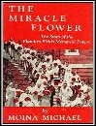 The Miracle Flower by Moina Michael. 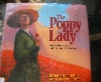 The Poppy Lady by Barbara E. Walsh Internet: http://www.greatwar.co.uk/article/remembrance-poppy.htm Websites: <https://www.alaforveterans.org/> Sign in and go to Committees, then Mission Outreach Committees, click on Poppy. Under Poppy Day Resources, find more Ideas, Bookmarks, Can Labels, Poppy Coloring Book, etc. In Resources, you can access the ALA Handbook or order it through Flag and Emblem sales 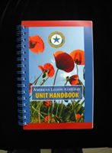 Plus our own website: <https://michalaux.org/>

**Poppy Committee Members** Chair-Christine Merlington 17259 Pringle St Sand Lake MI 49343 Contact 616-570-2830, [chrismsu63@yahoo.com](mailto:chrismsu63@yahoo.com) Committee Members-Alicia Minster (Unit 4 7th District) 49 West Josephine, Ecorse, MI 48229, [alisue_1121@yahoo.com](mailto:alisue_1121@yahoo.com) 248-242-0872

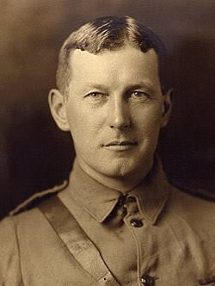 **The Poppy Story**  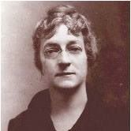

Lt. Col. John McCrae-Canadian, soldier, Moina Belle Michael-American teacher, physician, author & poet professor, patriot, activist for the Poppy symbol

In November 1918, The Ladies' Home Journal reprinted the poem, “We Shall Not Sleep,” now known as “In Flanders Fields,” by **LT. Col. John McCrae**. A field surgeon with Canada’s 1st Brigade Artillery, McCrae expressed his grief over “row on row’ of soldiers’ graves that had died on Flanders’ battlefields. The poem became a rallying cry to all who fought in the First World War.

Before the poem appeared in the Journal, John McCrae died. His words inspired **Moina Michael**, a teacher from Georgia and YMCA volunteer who worked with soldiers in New York City. To keep the message of the poem alive, Miss Michael resolved to wear a red silk poppy to honor these brave men and advocated for the poppy to be the symbol to remember and honor all veterans.

Her idea to mass-produce and distribute the flower throughout the country came to the attention of the newly established American Legion, VFW & other organizations. The poppy was officially adopted as the national symbol of remembrance by the Legion at their Cleveland Convention on Sept. 29, 1920. In 1921, during the first convention in Kansas City, Missouri, the Auxiliary added their support and agreed to distribute the flowers.

In 1924, the American Legion Auxiliary was given total responsibility for poppy production and distribution. The Poppy Program is now one of the oldest and beneficial Auxiliary programs for veterans and has kept the message of McCrae’s little poppy alive.

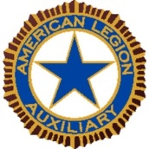

**The American Legion Auxiliary Poppy Poster Contest-Teacher Kit**

Greetings Educator!

Please consider including our American Legion Auxiliary Poppy Poster Contest as part of your curriculum. It is art, history and patriotism all rolled into one project!

The attached rules may seem lengthy…but basically it is creating a patriotic artwork on an 11 X 14 poster board. It must include 1 or more **red poppies**. It must say **American Legion** **Auxiliary** and it must have a fitting patriotic or memorial **slogan** (theme) that has 10 or fewer words. (It should not be humorous!) Write in ink on the back of the poster, which Class (I-VII), the student’s name, address, age, grade, Auxiliary Unit Name=___________________________ and Department of Michigan.

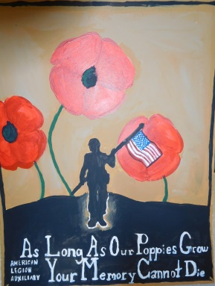 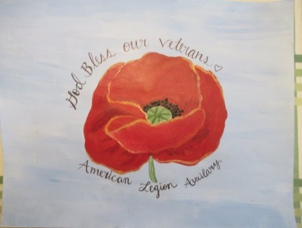 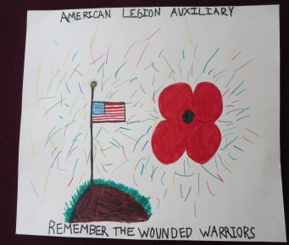 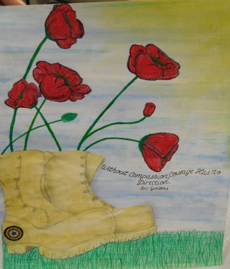

Previous poster examples

**Resources:** The WWI poem, “In Flanders Field” by Lt. Col. John McCrae, soldier, doctor, poet. Internet: http://www.greatwar.co.uk/article/remembrance-poppy.htm The book, The Poppy Lady, by Barbara E. Walsh. It is about a patriotic teacher & activist from Georgia, Monia Michael, who was instrumental in making the poppy the symbol of remembrance.

**Deadline is** _______________(It can be turned in earlier, but judging will begin after that date.) Our Unit is located at _________________________. Please contact ______________________ by phone___________________or email__________________________ with any questions.

*Thank You!*

**American Legion Auxiliary Poppy Poster Contest**-Official Rules

**The Poppy Poster Contest has seven classes:**

Class I Grades 2 & 3

Class II Grades 4 & 5

Class III Grades 6 & 7

Class IV Grades 8 & 9

Class V Grades 10 &11

Class VI Grade 12

Class VII Students with special needs *

Special needs are defined as: those students in special education classes; a student recommended for special education classes but not admitted due to wait list or other factors; a child identified as having a disability, but not in special education dues to lack of facilities.

**Poppy Poster Requirements**

1. Each poster shall have a fitting slogan not to exceed ten (10) words. The

articles “a”, “an”, “and”, and “the” are not to be counted words. The words

“buddy” and “buy” cannot be used.

1. The words “American Legion Auxiliary” must be used in the design of the

poster and will not be counted in the ten (10) word count.

3. Each poster must include one (or more) red Poppy.

1. The poster shall be 11 x 14 poster board. Drawing paper will not be accepted.
2. The United States Flag may be used as long as there are no infractions of the

Flag Code.

1. Posters will be judged using the following criteria:
   1. 50% - Poster appeal (layout, message, originality)
   2. 40% - Artistic ability (design and color)
   3. 10% - Neatness
2. Media used shall be watercolors, crayons, powder or oil paint, handmade

paper cut-outs, ink or textures, acrylics, pencils, and markers.

1. Written in INK on the back of the poster (not attached) shall be one of the above Classes (I-VII), student name, address, age, and grade of the contestant; name of the Unit and number=________________________ and Department of Michigan.
2. The poster shall be the work of only one individual.
3. No humorous drawings or slogans shall be used.
4. The label “In Memoriam” from the veteran-made poppy may not be used.
5. Submissions become
6. the property of the American Legion Auxiliary. We recommend taking a picture of your poster

